MUNICIPAL COUNCIL OF
BEAU BASSIN ROSE HILL


ANNUAL REPORT 2014

Mayor’s Statement


In line with Section 142 of the Local Government Act 2011, I am hereby submitting the Annual Report 2014 and the Unaudited Accounts of the Municipal Council of Beau Bassin Rose Hill for the period 1 January 2014 to 31 December 2014.

Ken Fat FONG SUK KOON, OSK
Mayor

Chief Executive’s Statement
Pursuant to Section 142 of the Local Government Act 2011, I have the honour to submit the Annual Report and Unaudited Accounts of the Municipal Council of Beau Bassin Rose Hill for the period 01 January 2014 to 31 December 2014.

S. TEELUCK
Supervising Officer

Organisation Profile
Council Vision
To be a Local authority achieving excellence in whatever it undertakes whilst being a close partner to all stakeholders.

Council Mission
Ensure that all the statutory duties including the services are delivered in accordance with the ever changing expectations of both the authorities and the citizens.

Council Values
Our corporate culture stands on values which places the citizen at the centre of our endeavours.
Those values are as follows:
• EXCELLENCE We will do our best within our financial means and with the human resources available to achieve excellence in our service delivery.
• EFFICIENCY We will strive to optimise our resources so that they are used in an efficient manner in order to accomplish our statutory duties.
• INTEGRITY We will act with integrity in all our dealings with our Stakeholders
• COURTESY We will act with courtesy in our relationships with the citizens, our employees, our suppliers and other stakeholders
• TEAMWORK We work as a team and believe that the citizens are part
of the network.
• QUALITY & INNOVATION - We will never stop ever-improving the quality of our services and endeavour to innovate so that the citizens are delighted with them
• COMMITMENT - The Municipal Council takes the undertaking that it is committed to serve the citizens of its township without any discremination.

Council Objectives

- Offer quality services
- Relate effectively and courteously with all the stakeholders
- Improve the corporate image
- Achieve a balanced financial situation year-in, year-out
- Attend to all complaints recorded through our Information and Service Centre or otherwise and keep the complainants informed of the outcome
- Treat with fairness
- Show transparency in rules, procedures, schemes and grievances

History and Profile
Beau Bassin-Rose Hill is a combination of French and English words. It reflects the successive occupations of the country by the French (1722-1810) and English (1810 till independence).
Beau-Bassin and Rose-Hill, two different localities were twinned and known as Town of Beau Bassin-Rose Hill, by virtue of Ordinance 31 of 1895. By the Proclamation No. 10 of 1896, it was administered by a Board of Commissioners consisting of seven members who were appointed annually by the Governor. The first Chairman of the board was Hon. Povah Ambrose.
As from 1950, the Town Council was constituted of eight elected members and four nominated members and later on the number of elected members had increased to twelve. On 12 March 1965, the Town Council was elevated to the status Municipal Council and was constituted of twenty-four elected members representing six members to each ward. The Chairman was then known as Mayor.
The town of Beau Bassin-Rose Hill has under its jurisdiction the several land conversions made by the ‘Compagnie des Indes’ between 1715 and 1767 and the subsequent additions of localities annexed. In 1963, the areas under the Village Councils of Trèfles, Stanley, Mont Roches, Plaisance were added to the Town and in 1964 some 440 acres, from Chebel branch Road to the Old Railway Track known as Coromandel, were transferred under the jurisdiction of the town. By 1991, the Town of Beau Bassin-Rose Hill, including Chebel and Morcellement Montréal covered an area of 20.2 km² and its population estimated to be 111,355 persons (Digest of Annual Statistics 2013 : Year 2012).

TWINNING
The Council has established twinning relationships with other international cities through which knowledge and ideas in various areas such as education, town planning, economic development, environment amongst others are exchanged.
The Council is twinned with the following towns/cities:
- Township of St Pierre (Reunion Island) since 1985.
- Village of Quartier Militaire since 1986.
- Town of Majunga (Madagascar) since 1996.
- Victoria (Seychelles) since 1996.
- Changzhou Municipal People’s Government (China) since 1997.
- Ethekwini Municipality (South Africa) since 2008
Places of Interest
Beau Bassin-Rose Hill is renowned for its commercial centres, for instance, the Arab Town, 'Arcades Sunassee', Galeries Evershine and several other shops along the Royal Road and the town centre.
This page is, however, focused on putting in the limelight, those places that truly stand out and worth visiting for anyone.
- Rose Hill Market
- Balfour Garden
- Daniel Bijoux Garden
- Germain Comarmond Garden
- Plaisance Fair
- Da Patten Fair
- Beau Bassin Market
- Sir Gaetan Duval Stadium
- Promenade Roland Armand
- Le Quorum
- Viewpoint Cascadelle
- Town Hall Yard
- Place Raymond Chasle
- Arab Town

Council Composition
The Municipal Council of Beau Bassin Rose Hill was composed of 18 elected members returned from 6 wards and allowance paid to them were as follows:
s.n.
Name |  | Total Allowance Paid
1 | ANDRÉ, Louis Toussaint | Councillor | 143,442.58
2 | ARLAPEN, Anita | Councillor | 117,000
3 | AUCKBARAULLEE-KHODABUX, Bibi Adiilah | Deputy Mayor | 149,611.64
4 | AUROKIUM, Gaetan | Councillor | 117,000
5 | BEGUE, Annie Georges | Councillor | 117,000
6 | BOUDOU, Philippe | Mayor | 297,607
7 | BUDLORUN, Baboo Bhoopendrasingh , | Councillor | 142,740
8 | CHOOLUN, Jai Krishna Vishwanauth | Councillor | 143,442.58
9 | CHRISTIAN, Marie Noëlle Sindy | Councillor | 117,000
10 | DAUREEAWOO, Rashad Racheed | Councillor | 366068.78
11 | FOO KUNE, Eileen Karen Lee Chin | Councillor | 142,740
12 | LAI KONG LING, Andy Kinsley | Councillor | 117,000
13 | PETIT, Eddy | Councillor | 117,000
14 | RAMENE, Marie France | Councillor | 117,000
15 | RAMSAMY, Mardaymootoo , also known as Niven | Councillor | 117,000
16 | RIVET, Michel Jules | Councillor | 142,740
17 | SAIRALLY, Hayatullah , also known as Hayat | Councillor | 117,000
18 | SANDAPA, Maryline Dominique | Councillor | 117,000

Administrative Team
Departments | Position | Name of Officer
Administration | Chief Executive | Mr. Jaylall Mulloo
Finance Department | Financial Controller | Mr. Daniel Lam Hing
Public Infrastructure Department | Head Public Infrastructure Department | Mr. Raffick Oodally
Public Health Department | Chief Health Inspector | Mr. Kailash Bagoban
Land Use and Planning Department | Head Planning and Land Use Department | Mr. Vijay Bangaroo
Welfare Department | Chief Welfare Officer | Mrs. Janeeta Soopal

Roles and Functions of Committees
Council Meeting
As required under Section 45 of the Local Government Act 2011, Council Meeting, presided by the Mayor, meets as often as its business may require and at least every fortnight in the Council Chamber to formulate general policy guidelines on the activities of the Council. The Municipal Council is made up of all elected councilors.

Executive Committee
Under Sections 47 & 48 of the Local Government Act 2011, the Executive committee is responsible for the determination of applications for Outline Planning Permissions and Building and Land Use Permits and for the approval of the procurement of goods and services the value of which exceed Rs 100,000. The term of office of an Executive Committee shall be 2 years and every decision taken by the Executive Committee shall be reported at the next Council Meeting. The Committee is comprised of the Mayor, the Deputy Mayor and 5 other members of the Council.

Permits and Business Monitoring Committee
As per Section 115 of the Local Government Act 2012, the Permits and Business Monitoring Committee has been set up to process every application for an Outline Planning Permission or a Building and Land Use permit with respect to the provisions of the Building Act, Town and Country Planning Act, Planning and Development Act and other relevant guidelines. All decisions taken therein are forwarded to the Executive Committee for approval. The Committee consists of the Chief Executive or his representative as Chairperson and the Heads of the Finance, Land Use and Planning, Public Infrastructure and Public Health Departments or their representatives.

Procurement Committee
Under the provisions of Section 160 of the Local Government Act 2011, any procurement of goods and services by the Council shall be determined by the Procurement Committee which is composed of the Chief Executive or his deputy; the Financial Controller or his deputy; and one senior officer in charge of a department other than that of the Chief Executive or the Financial Controller.

Public Infrastructure Committee
The Public Infrastructure Committee considers all matters pertaining to the management, and construction of all Municipal Assets/Infrastructure.

Public Health Committee
The Public Health Committee considers all matters pertaining to refuse collection, cleansing of public places, drains, bare lands, canals and rivers, roadside weeding, maintenance of public conveniences, rodent control and management of cemeteries and markets.

Welfare Committee
The Welfare Committee considers all matters pertaining to welfare, social, recreational, educational, sports and cultural activities.

Summary of number of meetings held in the year 2014
Committees | Number of sittings in 2014
Council | 28
Executive Committee | 48
Public Infrastructure Committee | 13
Public Health Committee | 12
Welfare Committee | 19
Permits and Business Monitoring Committee & Hearing | 58
Procurement Committee | 51
Bid Opening Committee | 27
TOTAL | 256

Local Disaster Risk Reduction Management Committee
Climate change is changing the face of disaster risk not only through weather related risks but also by rendering our society and the eco-system more vulnerable and the challenges posed by disasters and climate change in Mauritius have led to the setting up of a National Disaster Risk Reduction and Management Centre (NDRRMC) by the Government in the year 2013.
In the same line a Local Disaster Risk Reduction Management Committee (LDRRMC) under the Chairmanship of the Mayor has been set up to manage and reduce disaster risks that result from natural calamities and to reduce exposure to hazards by civilian population during a disaster scenario within the township.
As such the Municipal Council is called upon to play a major role in developing clear programs and action plans to address current hazards, manage risks/ uncertainties as well as build capacity to adapt and to become more resilient.
During the year 2014, the Local Disaster Risk Reduction Management Committee has met on three occasions (during the months of February, June and September 2014) and has also organised a table top simulation exercise on 14 November 2015 in collaboration with the NDRRMC and other stakeholders with regard to flooding at Seedoyal Lane Belvédère, Beau Bassin and a Landslide simulation at Hermitage Coromandel.

CORPORATE GOVERNANCE:
Good corporate governance is vital for providing people-driven service delivery and development and providing accountability and transparency.
Our vision and mission statements are displayed in all our departments and communicated to new recruits at induction stage itself. The efforts and integrity at work are always on the agenda of meetings between the Council and Management in order to promote our town as “Ville d’Excellence”.
All staff and employees are continuously being reminded that their actions should be centered on core ethical values like honesty and integrity.
Both formal and informal communications channels are used to inform staff of the probable consequences of corrupt actions, when discovered and are brought out for public scrutiny.
Systems checks and balances have been put in place firstly at the level of each department followed by investigations by the Internal Audit to monitor specific activities.
It is worth pointing out that the Council of Beau Bassin-Rose Hill has been the first Local Authority to have accepted the Anti-Corruption pledge in public in 2008.

Programme 1: Policy and Management of the Council
Priority Objective
- Ensure that Municipal services are provided to the satisfaction of citizens.
- Ensure that resources allocated to Departments are used judiciously.
- Ensure that Council’s policies are formulated and implemented within the framework of the Local Government Act and other laws.
- Exercise sound administrative and financial control.

Major Services
- Implementation of Council’s decisions.
- Delivery of Programmes as laid down in the Programme - Based Budget.
- Collection of revenue including arrears.
- Close monitoring of expenditure.

Administration Department
Headed by the Chief Executive and Assisted by his Deputy and the Assistants, the Administration Department is responsible for the Management and Administration of the day to day affairs of the Council
Among others, the Department is also responsible for:
- Implementing Local Government policies, goals and objectives.
- Implementing Local Government legislations and other relevant Legislations
- Initiating and implementing programmes aiming at enhancing the overall efficiency and effectiveness of the Council.
- Advising the Council in policy matters.
Under the Aegis of this Department the Council of Beau Bassin-Rose Hill has:
- The Human Resource Management Section
Headed by the Human Resource Management Officer and assisted by a Senior Human Resource Officer and other clerical staff. It deals with the follows:
- Appointment & Promotion, Retirement & Pensions and application of conditions of service.
- Monitoring leaves & attendances, passage benefits, car loans, travelling allowances.
- Dealing with Industrial matters and discipline of staff.
- Management of occupational, health, safety and welfare of employees.
- Issue, control and care of uniforms and Personal Protective Equipment.
- Human Resources Planning career development & Training of employees in line with the Council’s objectives & requirements.
Number of Employees in post for the year 2014: 792
Male: 592 Female: 200
Number of Employees on establishment: 901

Performance Management System (PMS)
Performance Management System is a management tool for good governance and improved performance which provides the opportunity to identity the development needs of employees at all levels in the organization within an agreed framework of planned goals, objectives, standards and competencies. The adoption of the system is in line with Government Programme which gives high priority to improving the performance of public service by developing capacity to perform and tackle poor performance.

Health & Safety Committee
Safety and Health Committees were conducted in line with the provisions of the Occupational Safety and Health Act 2005 to look into all health and safety issues at the Municipal Council.
For the year 2014 three (3) Safety & Health Committees were held.

Recruitments
Recruitment is done by the Local Government Service Commission and during the year 2014 two (2) Assistant Inspector of Works, one (1) Civil Engineer and one (1) Carpenter were recruited.

Retirements
During the year 2014, two (2) Refuse Collectors, two (2) Handy Workers, one (1) Driver, (1) Infant School Teacher, (1) watchman, (1) Overseer and (3) General Workers retired from the service.

Training and Development
To ensure that service delivered is enhanced and to keep abreast with the latest trends as well as improve efficiency, training opportunities are provided to officers whenever possible.
Heads of Departments and officers have attended training programmes, seminars and workshops as follows during the year 2014:
Training for year 2014
Post | No of officers | Period | Institutions
Accountant | 1 | 08-12 Sept-14 | Ministry of Environment & sustainable development
Accountant | 1 | 21-22 Jul-14 | Ministry of Local Government
Ag Deputy Chief Executive | 1 | 15-May-14 | Independent Commission Against Corruption
Assistant Financial Operations Officer | 2 | 3-Jul-14 | Competition Commission of Mauritius
Assistant Financial Operations Officer | 2 | 21-22 Jul-14 | Ministry of Local Government
Assistant Inspector of Works | 1 | 13-Jun-14 | Independent Commission Against Corruption
Assistant Procurement & Supply Officer | 1 | 3-Jul-14 | Competition Commission of Mauritius
Building Inspector | 1 | 20 Oct to 26 Nov 14 | Ministry of Local Government
Cadastral Assistant | 1 | 31-May-14 | Min of Housing
Cadastral Officer | 1 | 31-May-14 | Min of Housing
Chief Health Inspector | 1 | 3-Apr-14 | Ministry of Local Government
Civil Engineer | 1 | 27-Nov-14 | Ministry of public infrastructure
Engineering Assistant | 1 | 18-Sep-14 | Construction Industry Development Board
Financial Controller | 1 | 21-22 Jul-14 | Ministry of Local Government
Head Public Infrastructure Dept | 1 | 15-May-14 | Independent Commission Against Corruption
Head Public Infrastructure Dept | 1 | 11-Jun-14 | Mauritius Research Council
Head Public Infrastructure Dept | 1 | 27-Nov-14 | Ministry of public infrastructure
Head Public Infrastructure Dept | 1 | 21-23 Jul-14 | Prime Minister's Office
Health Inspector | 1 | 13-Jun-14 | Independent Commission Against Corruption
Health Inspector | 1 | 2-Jul-14 | Mauritius Research Council
Health Inspector | 1 | 01-05 Dec 14 | Min of Environment
Librarian | 1 | 13-Jun-14 | Independent Commission Against Corruption
Librarian | 1 | 16-Dec-14 | Mauritius Council of Registered Librarians
Librarian | 1 | 24-Mar-14 | Mauritius Council of Registered Librarians
Library Clerk | 3 | 24-Mar-14 | Mauritius Council of Registered Librarians
Library Officer | 1 | 24-Mar-14 | Mauritius Council of Registered Librarians
Library Officer | 1 | 25-Mar-14 | Mauritius Council of Registered Librarians
Management Support Officer | 1 | 13-Jun-14 | Independent Commission Against Corruption
Planning & Development Inspector | 1 | 20 Oct to 26 Nov 14 | Ministry of Local Government
Planning and Development Inspector | 1 | 14 Jul to 17 Sept 14 | Ministry of Local Government
Principal Financial Officer | 2 | 3-Jul-14 | Competition Commission of Mauritius
Principal Health Inspector | 1 | 20 Oct to 26 Nov 14 | Ministry of Local Government
Senior Health Inspector | 2 | 3-Jul-14 | Competition Commission of Mauritius
Senior Health Inspector | 1 | 31-May-14 | Ministry of Health & Quality of Life
Senior Health Inspector | 2 | 14 Jul to 17 Sept 14 | Ministry of Local Government
Senior Health Inspector | 1 | 20 Oct to 26 Nov 14 | Ministry of Local Government
Senior Inspector of Works | 1 | 20 Oct to 26 Nov 14 | Ministry of Local Government
Senior Librarian | 1 | 25-Mar-14 | Mauritius Council of Registered Librarians
Senior Library Clerk | 1 | 25-Mar-14 | Mauritius Council of Registered Librarians
Tradesman Assistant Mechanic | 1 | 13-Jun-14 | Independent Commission Against Corruption
Usher/Prosecutor | 2 | 14 Jul to 17 Sept 14 | Ministry of Local Government
Welfare Officer | 1 | 13-Jun-14 | Independent Commission Against Corruption
- The Committee Section
Headed by a Senior Committee Clerk and assisted by three Committee Clerks this section is responsible for :
- Recording of all minutes of proceedings of Committees
- Establishing calendar for meetings.
- Circulating the minutes of proceedings among staff and councillors.
- Ensuring timely dispatching of all notice of meetings etc.
- The Internal Control and Audit Section
Internal Control is important to ensure the efficiency and effectiveness of operations and adherence to best practices, rules, and regulations as is part of day-to-day management.
An essential part of Internal Control is Internal Audit which is involved in carrying out daily checks over all financial activities of the Municipal Council. Audit is also carried out in cash collection, expenditure, payroll, stores, cash book amongst others.
- Information Technology Section
The IT Section is responsible for the introduction, deployment, maintenance and upgrading of all Information Technology Infrastructures of the Municipality and to also advise the Council on all IT matters.

Projects for 2014
  - Setting up of the Local Authority’s Portal – http://la.govmu.org
  - Online application for BLP
  - E-Payment Facility for BLP

- Information and Service Centre (ISC)
The Information and Service Centre is responsible for registering complaints, grievances and suggestion from the public and to channel the respective complaints to the respective department for actions.

- The Municipal Library
The Olof Palme Municipal Library, created in 1946, was ISO Certified in April 2004 by Mauritius Standards Bureau. Regular auditing and assessment are carried out by auditors of Mauritius Standards Bureau to ensure library compliance with ISO. As per ISO Standards, we aim at providing quality service and seek to continuously improve our services to meet the diverse and new emerging information needs of our users.
The library has a collection of more than 45,000 books and subscribes to some 34 titles of foreign magazines. Most of the daily and weekly local newspapers are available on spot consultation in the main library and branch libraries.
Services of the library are:

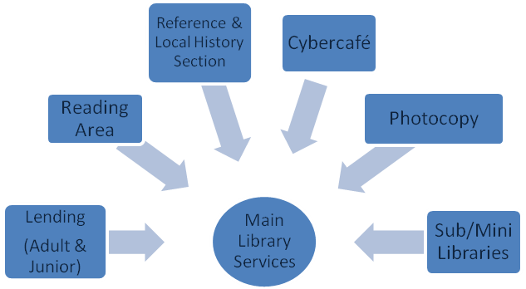

The library has one sub library and eight mini libraries as follows:
- Maingard Sub Library
- Camp Le Vieux Mini Library
- Mare Gravier Mini Library
- Chebel Mini Library
- Plaisance Mini Library
- Trèfles Mini Library
- Mont Roches Mini Library
- Stanley Mini Library
- Les Chebecs Mini Library

Maingard Sub Library provides lending and free Internet services while the mini libraries provide mostly on spot reading and Internet services. Free Wifi facility is also available in the Municipal Library.

Main Library opening hours:
Summer Time: Weekdays from 9.00 a.m. to 5.30 p.m. (November to April)
Winter Time: Weekdays from 9.00 to 5 p.m. (May to October)
Saturdays: 9.00 a.m. – 3.00 p.m.

Mini Libraries: Opening Hours
The mini libraries are mostly opened after 2.30pm during weekdays and after 1.00 p.m on Saturdays. Complete details of the opening hours are available on the Municipal website

Books:
Some 100 new adult books are released monthly and childrens’ books are put on shelves in January and during school holidays (April, July & December). List of new books are available on our Municipal website.

Binding Section:
New books are bound and old or damaged ones are rebounded or repaired for the library. The binding section also provides a binding service to the other departments of the municipal council.

Activities :
The library has also organised a series of literary activities for students of primary and secondary schools in Beau Bassin-Rose Hill.

Literary activities organised are:
Primary Schools
- Quiz Competition (06th March 2014)
- Concours d’Orthographe ( 08th February 2014)
- Lecture à Haute Voix, ( French) and Reading Aloud ( English) (03rd March 2014)
Secondary Schools
- Quiz Competition (10th March 2014)
- Des Chiffres et Des Lettres competition (30th May 2014)
A prize giving ceremony was held on the 19th March 2014 for the Quiz Competition, Concours d’Orthographe and Lecture à Haute Voix while for “Des chiffres et Des Lettres Competition” the prize giving ceremony was held on the 6th of June 2014.

More than 95% of primary schools and some 50% of secondary schools of Beau Bassin/Rose Hill have participated in these activities.

Futher projects/activities/services:
- Organising activities to promote reading in the remote regions of Beau Basin/Rose Hill.
- To equip the library with Air- Conditions.
- To provide Wifi facilities within the library.
- Creation of a new library in Tréfles.

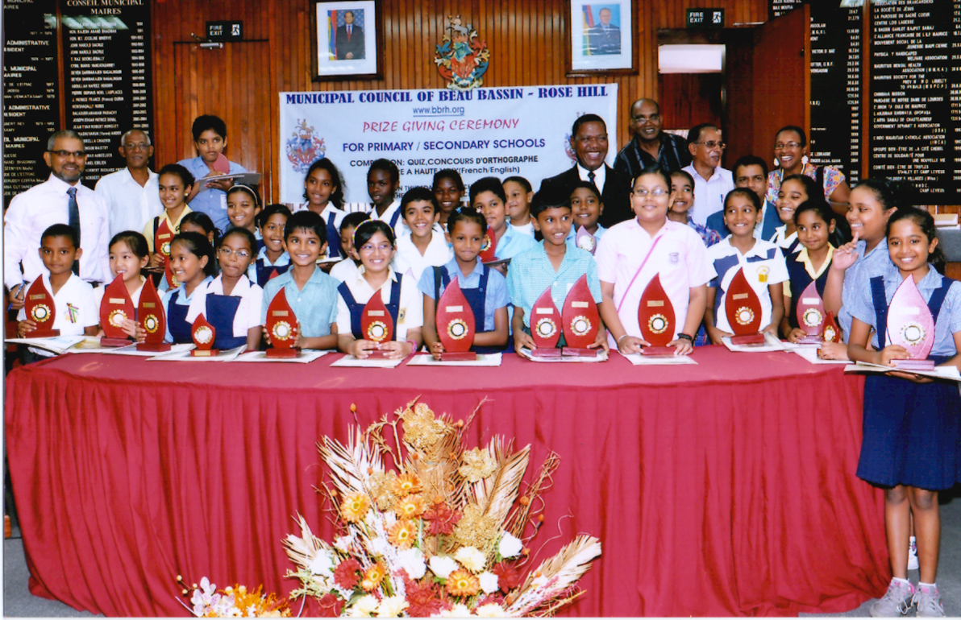

Visitors to the library for the year 2010 - 2014
Year | No. of visitors
2010 | 37263
2011 | 70600
2012 | 45135
2013 | 78591
2014 | 81025
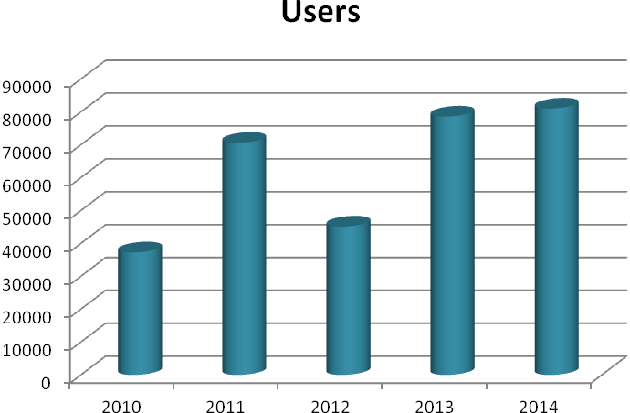

New Acquisition for the year 2010 to 2014.

Year | New books
2010 | 1563
2011 | 1417
2012 | 3561
2013 | 2605
2014 | 3561
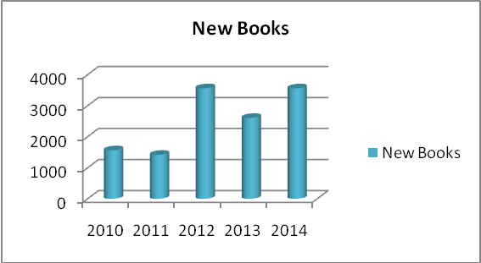

The total budget for the Library section for the purchase/acquisition of books, periodicals, newspapers etc. amounts to Rs 859,267 for the year 2014.

The actual amount spent for 2014 is as follows:
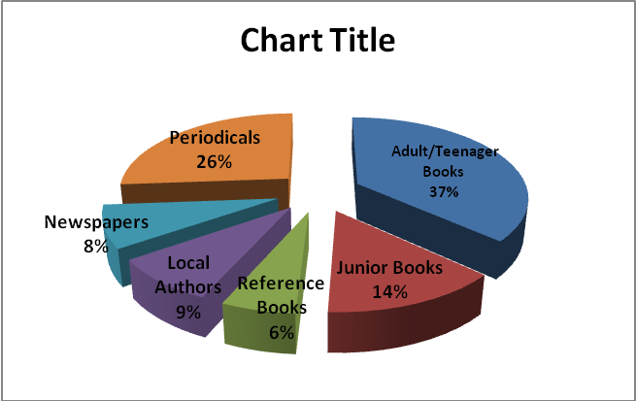
Materials | Actual Amount (Rs)
Adult/Teenager Books | 315,907
Junior Books | 120,975
Reference Books | 50,000
Local Authors | 75,000
Newspapers | 72,385
Periodicals | 225,000

Finance Department

The Finance Department is responsible for the proper management of Municipal finance. The Financial Controller is the principal adviser on financial matters to the Council. He is responsible to see to it that proper systems of internal control and accounting are established in every department, that public revenue is collected promptly and properly accounted for, and that expenditure and other disbursements are properly made under the correct votes and items of the estimates.
The Finance Department is managed through the following sections:
- Pay Section – in charge of all pay transactions pertaining to employees benefit.
- Procurement Section – responsible for the procurement of goods and services as may be required by the Council in accordance with the Public Procurement Act; keeping proper records for requisitions, quotations and procurement, etc; the calling of quotations from different suppliers and to order goods and services with limit of funds available after decision has been made for the procurement thereof.
- Income Section – Collecting taxes, fees, rent and monies due to the Council.
- Expenditure Section – Close monitoring of day to day expenses of the Council and payments of bills.
- Usher/Prosecution Section – responsible for the Collection of debts

Major Constraints and Challenges and how they are being addressed

- The quantum of our Grant-In-Aid need be reviewed.
- Recovery of arrears is cumbersome and time consuming.
- Delay in valuation of properties

Strategic Direction 2015-2017

- Land Administration Valuation Information Management System (LAVIMS) project will provide an effective tool for a better management of all immovable properties located within our township for the purpose of assessment, taxation, social and economic decisions in the future. The LAVIMS project will also assist in local government financing decisions.

- The provision of the law for self assessment of properties will be reinforced.

SUMMARY FOR YEAR 2014
Code | Programmes | REVISED ESTIMATES 2014
Code | Programmes | Rs
1 | Policy and Management of the Council | 124,437,909
2 | Provision and Maintenance of community-based infrastructure and amenities | 104,080,824
3 | Development Control within Council’s Areas | 6,812,396
4 | Sound and healthy conditions in the Council's area | 100,813,362
5 | Promotion of Sports, Welfare, Education and Cultural Development | 55,292,107
TOTAL |  | 391,436,598
SUMMARY BY ECONOMIC CATEGORIES
Code | Economic Categories | 2014  Revised Estimates
Code | Economic Categories | Rs
21 | Compensation of Employees | 255,918,233
22 | Goods and Services | 85,743,365
24 | Interest | 1,700,000
27 | Pension & Gratuities | 38,250,000
28 | Contributions to AIMF,AVCOI etc | 400,000
31 | Acquisition of Non-Financial Assets | 9,425,000
32 | Acquisition of Financial Assets | -
Total Expenditure |  | 391,436,598
SUMMARY OF EXPENDITURE
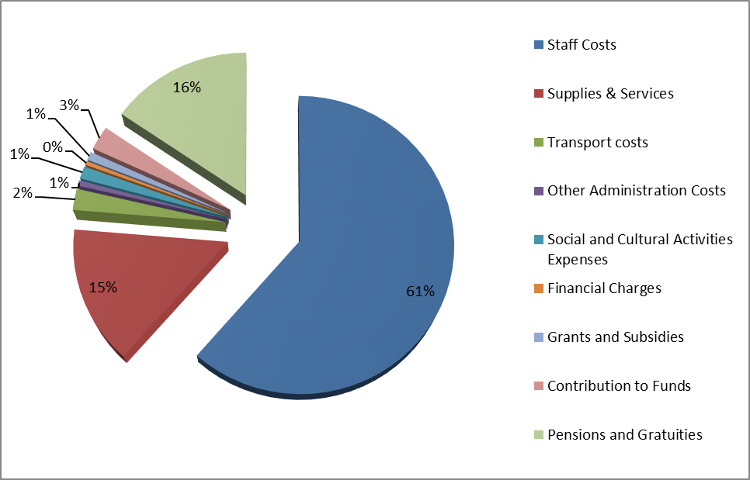

SUMMARY OF INCOME
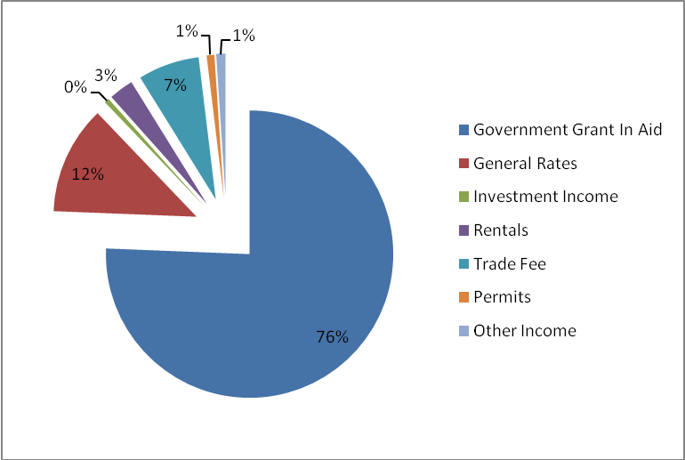

Income of the Council

Grant In Aid
An amount of Rs 291.5M was received as Grant in Aid from the Central Government for the year 2014 which represent 76% of the total revenue of the Council.

Own Sources of Revenue
- General Rates
- Classified Trades
- Other Incomes
  - Building and Land Use Permits
  - Publicity Fee
  - Rentals of Halls
  - Investment Income
  - Other Miscellaneous Incomes such as Bus Toll, Obstruction of Roads etc.
Programme 2: Provision and Maintenance of Community Based Amenities
Priority Objective
- Ensure the useful life of community based infrastructure is enhanced.
- Reduce flooding areas and ensure proper evacuation of running water through the construction and maintenance of drains.
- Provision of well accessed non classified roads with traffic signs and proper road marking.

Major Services

- Construction and maintenance of non-classified roads.
- Construction and maintenance of drains.
- Installation and maintenance of Street lighting points.
- Road marking-3600M2 and replacing and maintaining traffic signs.
- Maintenance of Council's assets e.g buildings, sports infrastructure, etc.
- Implementation of key infrastructure projects.

Public Infrastructure Department
The department has a staff of 232 workers and its functions/services are as follows:
- Construction, repairs and maintenance of drains to ensure proper evacuation of rain water and reduce flooding areas;
- Provision of well accessed non classified roads with traffic signs and proper road markings;
- Construction and maintenance of non-classified roads;
- Installation and maintenance of street lighting points;
- Road markings and maintenance of traffic signs;
- Maintenance of Council’s assets, e.g. buildings, sports infrastructure, etc.;
- Implementation of key infrastructure projects.
- Repairs and maintenance of fleet of municipal vehicles and plants.
- Processing of building permits and morcellement applications.
- Designing and implementing infrastructural projects related to buildings, roads, bridges, drains, pavements, lighting, playgrounds, sports grounds, social halls, traffic centres, markets, fairs, crematoria, exhibition halls, art galleries, public libraries etc.
- Upkeeping, maintenance, upgrading and setting up of new gardens and green spaces.

- ROADS
Works carried out for the year 2014

- Resurfacing/tarring/reprofiling of road
- Racine Street, Residence Barkly
- MahadeoBiltoo Lane (Persand Lane)
- Lane off Swami Dayanand (Faridas Lane)
- Lane off Martindale (Perrine Lane)
- Lane off Maha Vishnu Temple Road
- Lane off Palmier – Residence Vuillemin
- Swami Dayanand Lane – public road
- Duperré Lane
- Lane off Swami Dayanand (Sadulla Lane)
- Mare Gravier Complex
- Mere Theresa, Chebel
- Sports Complex, Coromandel
- Lane off Royal Road, Belle Etoile
- Lane off Pavéd’Amour, Coromandel
- Sirius Lane, MorcellementBolah, Trèfles
- Lane off Dr Reid (Rajkumar Lane)
- Lane off Brunet (Mosafeer Lane)
- Lane off Swami Dayanand (Hossen& others)
- Lane off 51, Royal Road, Beau Bassin (Peeroo Lane)
- Lane off Martindale (Dauhoo& others)
- Lane off Dr Reid (Boodhoo& others)
- Arnaud Street
- Lane off Dupont (Digumbar& others)
- Lane off Pope Henessy (Naraidoo& others)
- MorcellementBolah, Trèfles

- DRAINS

The Council labour effects regular maintenance to open and covered drains. Moreover, construction of collector and absorption drains are also carried out. The following drains have been constructed during year 2014:
- By In-house labour:
- White House Lane, Coromandel
- Morcellement Patter, Chebel
- RamparsadSeedoyal Street, Beau Bassin
- Arrighi Street, Beau Bassin
- Dupont Street Beau Bassin
- Swami Dayanand Lane, Beau Bassin
- 5th Mile, Beau Bassin

- By contractors:
- E. Anquetil Avenue
- Irlen Street
- Impasse Pillay
- Tamarinier Avenue
- FareedMuttur Avenue
- Prince Charles Street
- Impasse Barbier
- Monsieur Street
- France Boyer de la Giroday, Plaisance
- Raymond Peril/Abbe Harel
- Wellington Street
- Mamzelle Street , Mont Roches
- Cosmos Street, Barkly

- PROJECTS
Projects carried during year 2014 are as follows:
- Embellishment of Canal La Ferme from Dr. Jeetoo to Bradshaw
- Footpath along Nelson Mandela Street, Barkly
- Construction of a Funeral Parlour at Camp Levieux

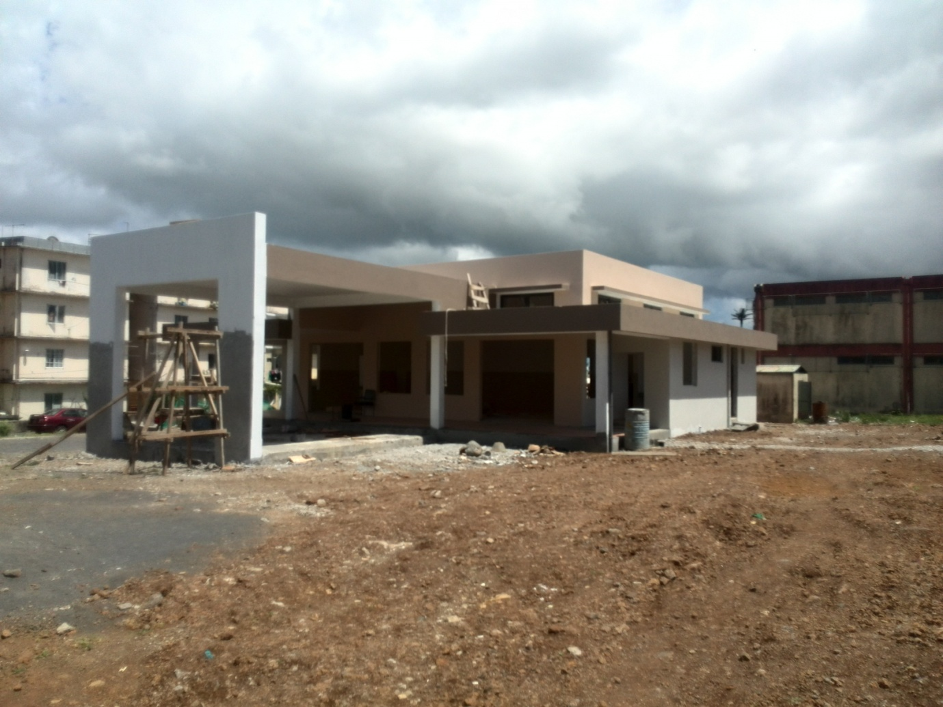

- Construction of a Mini Library at Mozart Family Corner, Trèfles
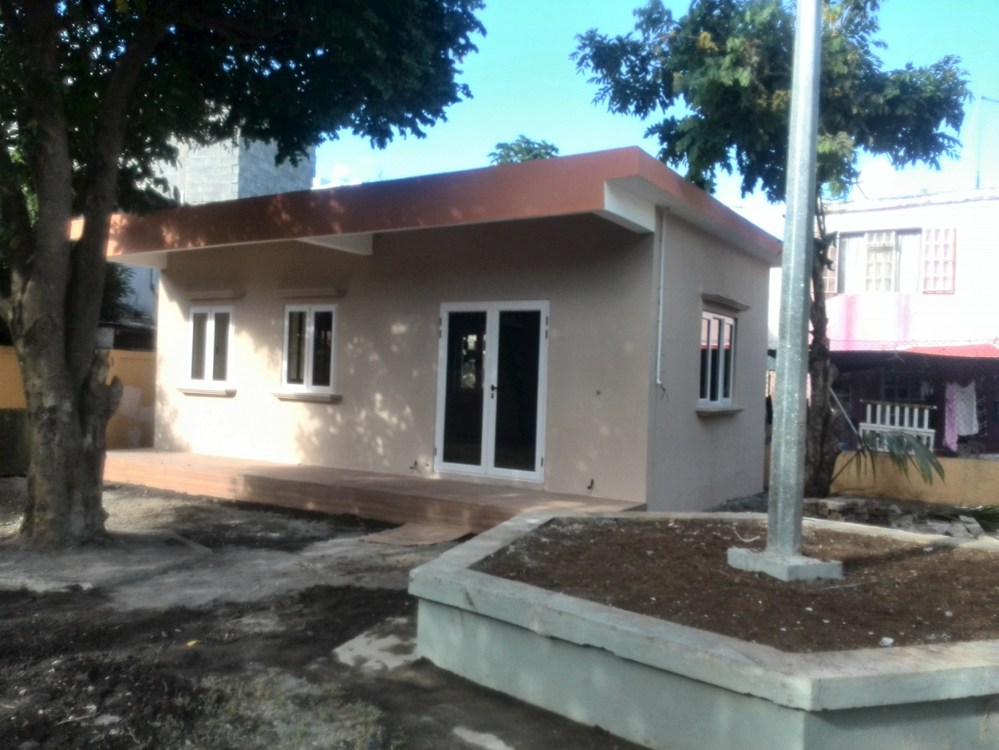
- Upgrading of Social Hall at Mare Gravier
- Upgrading of Social Hall at Mere Theresa, Chebel, Beau Bassin
- Upgrading of Children Playground at Chebel
- Upgrading of Sports Complex at Kosovo

- GREEN SPACES

Upgrading/ Creation of the following green spaces were carried out during year 2014
- Bam Cuttayen at Mont Roches
- Vuillemin Family corner
- Chebel family corner
- Bradshaw Family corner, Trèfles
- Cretin Family corner, Camp Levieux
- Mozart Family corner, Trèfles
- Square Avrillon, Plaisance
- FareedMuttur Square, Plaisance
- Centre de L’Unité R20, Camp Levieux
- Chavrimootoo Green Space, Barkly

- STREET LIGHTING
Fixing of new complete street lanterns: approximately 100

- PURCHASE OF NEW VEHICLE/EQUIPMENT

The following equipment/lorries were purchased by the Municipal Council in 2014
- 1 Low Bed Trailer
- 1 Skid Loader
- 1 Vibrating Plate Compactor
- 1 Double Cabin Street Lighting Lorry with Aerial Telescopic Platform
- 2 Tipper Lorries
- 1 Compactor Lorry

PROGRAMME 3 – Development Control within Council’s Areas
Priority Objective
- Promote a harmonious, orderly and sustainable development within the Council's area.
- Process and issue of Building and Land Use Permits (BLUP) and Outline Planning Permission (OPP) as provided in Section 117 of the Local Government Act 2011 and in compliance with provisions of the Outline Planning Scheme, Planning Policy Guidance and guidelines/regulations applicable, the Building Control Act 2012, the Town and Country Planning Act 1954, the Planning & Development Act 2004 and the Environment Protection Act 2002.

Major Services

- Issue of Building and Land Use Permits.
- Dissemination of information to citizens on guidelines & procedures relating to issue of permits.
- Ex Post Control (Building, Planning and Development Controls) to ensure compliant-development.
- Continuous updating of our Municipal Cadastre.

The Department is responsible for
- Issue of BLUP for
  - Construction of Buildings for various uses (Residential, Commercial, Services, Industrial & Sui Generis).
  - Construction of Boundary walls along public roads
  - Excision of land and subdivision of land among heirs (subject to Morcellement Act)
- Carry out Ex Post Control (Building, Planning and Development Controls) to ensure that:
  - Persons having been issued with a BLUP are complying with the approved plans and conditions attached.
  - Compliance Certificate is issued to all newly completed and occupied buildings.
  - Survey of properties so as to ensure that timely assessment by Valuation Office or Self Assessment by Valuation Office or Self Assessment for rating purposes.
- Attend to complaints from members of the public and take appropriate actions including serving Request Notices as well as taking legal actions against illegal development.
- Submit recommendations to the Morcellement Board of the Ministry of Housing and Lands for Morcellement Permits application, to the Land Conversion Committee of the Ministry of Agro Industry & Food Security for Land Conversion Certificates/Permit/Certifiactes and to the Ministry of Environment, Sustainable Development, Beach and Disaster Management on applications for Environmental Impact Assessment Licence and Preliminary Environmental Reports

(II) Self Assessment
A total of 55 individuals, companies or societe has been referred for self-assessment with a view to generate rate/tax for newly occupied buildings.

(III) Online BLP
Introduced to enable residents and developers to apply for a BLUP and make payment online using the Internet to access the online system via the Government Online Centre.

(IV) Notices
147 Notices have been served upon offenders/contravenants for breach of legislations or conditions attached to BLUP issued out of which 33 cases were lodged before the Lower Plaines Wilhems District Court, 41 cases complied, 31 submitted BLUP applications in view to comply with notices and 42 cases are still being monitored.

Municipal Council of Beau Bassin/ Rose Hill
Building and Land Use Permit Applications for Year 2014
Application Type | Development Category | No. of Application registered-2014 | No. of Permits  approved-2014 | No. of applications  rejected-2014 | No. of Applications amendments not submitted- 2014 | No. of Building and Land Use Permit not collected- 2014
BLP1 | Residential Development not exceeding G + 3 levels, not exceeding 4 units | 404 | 355 | 5 | 44 | 1
BLP3  (Economic activities) | Commercial | 62 | 52 | 7 | 3 | Nil
BLP3  (Economic activities) | Services | 30 | 12 | 1 | 17
BLP3  (Economic activities) | Industrial | 15 | 6 | Nil | 9 | Nil
BLP3  (Economic activities) | SMEDA | 1 | 1 | Nil | Nil | Nil
BLP3  (Economic activities) | SuiGeneris | 3 | Nil | 1 | 2 | Nil
BLP3  (Economic activities) | Outline Planning Permission | 3 | 1 | 1 | 1 | Nil
 | Exempt Development | 507 | 382 | 63 | 43 | 19
Subtotal |  | 1025 | 809 | 78 | 119 | 20
BLP2 | Morcellement-'Excision/Subdivision of land among heirs' | 79 | 63 | 1 | 15 | Nil
Total |  | 1104 | 872 | 79 | 134 | 20
Programme 4: Sound and healthy conditions in the Council's area.
Priority Objective
- The Collection, removal and disposal of household, industrial, commercial and agricultural wastes and other refuse.
- Management of public Markets and Fairs.
- Control of hawkers.
- Creation of a salubrious environment in the Council's area through the provision of an efficient refuse collection, regular cleaning and maintenance of public places such as open spaces, parks, gardens, bus shelters, public buildings including lavatories.
- Regular maintenance of drains and roads.

Major Services

- Refuse collection and their disposal.
- Cleaning of public places including bare lands.
- Rodent and pest control.
- Information/Education and Communication (IEC) campaigns to local community.

Public Health Department
The Public Health Department is responsible for:
- Scavenging Service
- Control and cleaning of barelands
- Public Toilets
- Collection of Trade, Publicity & Advertisement, Occasional licence fees
- Carrying out inspection for ex-post control with regard to the implementation of the provisions of The Business Facilitation Act(2006)
- Control of Hawkers
- Market and Fairs
- Rodent Control
- Enforcement of the Local Government Act 2011 and all relevant legislations with regard to environmental and public health.
- Maintenance of cremation grounds.

Scavenging Service
The ¾ of the scavenging service is provided in-house and the remaining ¼ by contracted services,
For the delivery of a regular and timely scavenging service, the Health Department relies on a work force as follows:

Health Inspectorate: Health Inspectors 11
Overseers: 1
HMU/Driver Scavenging Supervisors/Driver/Relief Driver: 29
Refuse Collectors: 258
General Workers: (Female): 22
Chemical Sprayermen: 7

The Health Department has a fleet of 24 scavenging vehicles,.i.e 20 tipper lorries and 4 compactor lorries.

Scavenging service is provided once weekly to all households except to the inhabitants of the eight Residences (formerly called Cités) who benefit from a twice weekly service.

The scavenging contractor provides a thrice daily service to the commercial areas of the town and a weekly service to the other residents.

Weeds on road sides are cut by bush cutters and later are sprayed with herbicides.
The Council also provides special service to places of worship and their vicinities during the various religious festivals throughout the year.

Paid Lorry Service
For collection of green wastes from private premises a paid lorry service (with or without labour) is provided by the Council. For the year 2014, 277 trips were performed and generated revenue of Rs 221,400.This service, whilst helping the citizens and keep off the road green wastes, ease off pressure on the normal scavenging service.

Bulky Waste Campaign
Bulky wastes campaigns were organized in the months of November and December in the different parts of the town, namely NHDC Camp Levieux, Nelson Nelson Mandela St, Barkly.
New regulations for disposal of refuse were promulgated

Wastelands
In 2014, 597 request notices were issued upon owners to cause their property to be cleaned. 454 wasteland, whose owners are unknown, were cleaned by the municipal council.

Public Toilets
The municipal council runs public toilet at the places listed below:
- Cardinal Margeot Square, Rose Hill - Additional of a pay public toilet
- Rose Hill Market
- Da Patten Fair Plaisance Fair
- Place Pierre Renaud, Beau Bassin
- Beau Bassin Market
- Barkly Fair, Résidence Barkly. (not in operation)

A paid public toilet, the first of its kind in Mauritius, came into operation in 2013. The cleaning of the public toilets listed below is entrusted to private contractors:
- Place Margeot Square, Place Pierre Renaud and Town Hall yard.

Collection of Trade Fees
Fees collected by the Health Department for the different economic activities are as hereunder. The figures reflect the prevailing economic situation in country and fees –collected depend on private initiatives to create new businesses. Ex-post control is carried out by the health inspectorate to track down those who have failed to pay the trade fees or those who have ceased business and who have failed both to notify the council and pay the relevant fees due.

SN | PARTICULARS | NO.
1 | Existing Trade Licence | 6056
2 | New Trade Licence | 654
3 | Trade which has ceased | 98
4 | Contraventions issued to debtors | 431

Control of Hawkers
To keep the public thoroughfare and pavements of the town free of illegal hawkers with a view
- to ensure the safety of pedestrians,
- to prevent the proliferation of pickpockets and drug peddlers,
- to enforce law and order in general and
- to ensure that the interests of law abiding traders are not interfered with, the municipal council carried out a strict control of hawkers in the town.

71 seizures of articles have been made and 78 contraventions established against illegal hawkers during the year 2013.

Markets and Fairs.
New Markets/Fairs Regulations implemented.
The following municipal market and fairs fall under the responsibility of the Health Department which has to look after their administration and their maintenance on a daily basis.

These are:
- Rose Hill Market
- Da Patten Fair
- Plaisance Fair
- Beau Bassin Market and
- BarklyFair. (not in operation)
Six Health Inspectors are posted at these Market and Fairs for enforcement of Market and Fair Regulations. Seventeen General workers are posted at these markets and fairs for cleaning and washing purposes.

Rodent Control
The Health Department is also responsible for the control of rodents and pests in the municipal administrative buildings, agglomerations (Residences), open spaces and gardens, Markets and Fairs, social halls and pre-primary schools, mini libraries and sports complex. This is a contracted service which is done twice monthly.

Enforcement of Local Government Act and all relevant legislations with regard to environment and public health

ISC Complaints
The inspectorate has carried out inspections to attend to 766 complaints received from the public and these concerned abandoned houses, breeding of animals, barelands, illegal dumping, illegal trades, refuse collection etc…
Majority of the complaints were attended.

Cremation Grounds
The responsibility of maintenance of the two municipal cremation grounds at Camp Levieux and Chebel fall under the responsibility of the Health Department which ensure that the lawn are mowed and weeds removed regularly. The premises of the cremation ground are swept as often as required. Ashes are disposed of in a proper manner.
A new incinerator was under construction at Chebel and will be completed by this year.

PROGRAMME 5 - Promotion of Sports, Welfare, Education and Cultural Development
Priority Objective
- Provision of social and cultural activities.
- Provision of free pre – primary education.
- Promotion of sports and support to local sports teams.
- Enhance literacy by facilitating access to books, magazines, internet etc.
- Rehabilitation of playing grounds.

Major Services

- Organisation of cultural and social activities.
- Organisation of sports activities and support to sports clubs.
- Support to other clubs affiliated with the Council.
- Managing pre - primary schools.
- Provision of educational, IT and literary and other facilities.
- Consolidation of centralised and decentralised library facilities.

The Welfare Department is called upon to provide logistics to Socio-cultural Associations to organise cultural activities and to act as facilitator and co-ordinate assistance on the following occasions:-

Thaipoosam cavadee was celebrated on 17 January 2014. The following facilities were provided:
- Financial Grants
- Water Tanker
- Cleaning around the vicinity of kovils
- Scavenging services and Plastics Bags
- Lighting Services

Chinese Spring Festival
A Lantern Festival in collaboration with Ping On Senor Citizens Club was organised on 15 February 2015 at La place des Taxis , Beau Bassin (Danses du Dragon & du Lion, Musiques Traditionnelles, demonstration D’Arts Martiaux, Tai Chi, kung Fu & Coin Cuisine Traditionelle, spectacle surprise avec Master Ng).
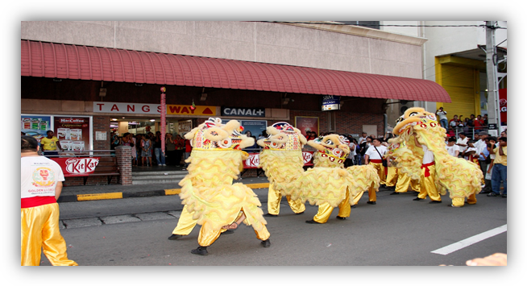
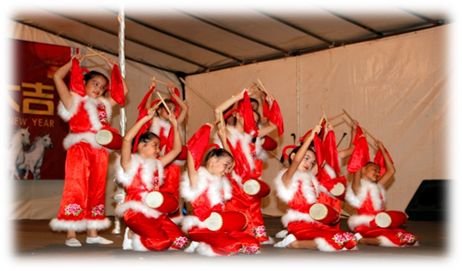

Maha shivaratree was celebrated on 27 February 2014 and the following facilities were given:
- Financial Grant
- Scavenging services /plastic bags
- Lighting Services
- Centre d’acceuil at vendermesh (For 3 days) foods were distributed and sleeping facilities were provided to pilgrims.

Easter celebrations
- Easter eggs were distributed in all Municipal Pre –Primary Schools, APEIM and Hospices of the Town.
- Cakes were distributed to Churches.
- Mass: Facilities such as Tent, Podium, Chairs, lighting, Public Address were provided to associations/ paroisse.

National Day Celebrations
- A flag raising ceremony was held on 11 March 2015 at all Municipal Kindergartens and for all municipal employees in Plaza Yard.
- A Play Day was organised on 13 May 2014 at Sir Geatan Duval Stadium with all Municipal Pre-Primary Children.


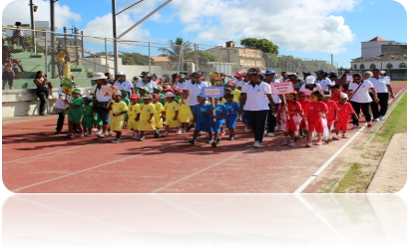

- 9 A-Side Football Festival (Independence Cup 2014) was organised as from 16 March 2014 at the following regions:
  - N.H.D.C Camp-Levieux
  - Plaisance / Rose Hill
  - Barkly
  - Mont Roches/Roches Brunes
  - Stanley/Tréfles
  - Chebel/ Coromandel

The final was held on Sunday 27 April 2014 at Sir Gaetan Duval Stadium.
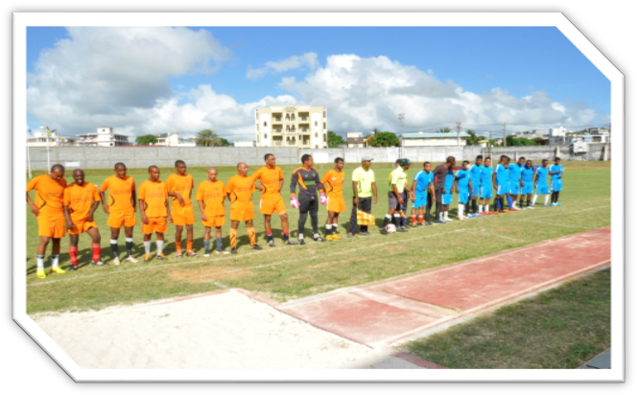



- An Open Petanque Tournament (Independence Cup 2014) in collaboration with Beau Bassin Rose Hill Petanque Regional Committee was organised on 6th April 2014 at Quorum Petanque Pitch, Plaisance.

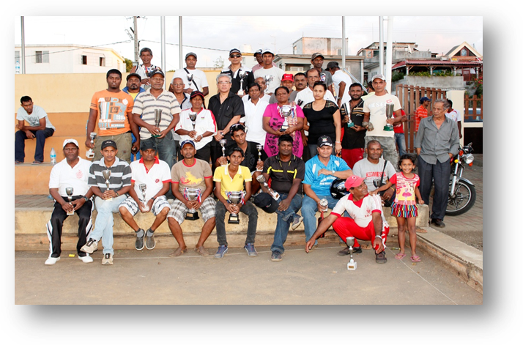

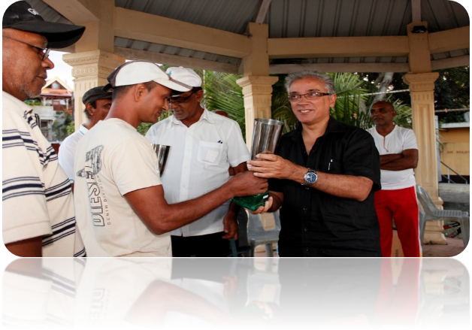

- A Gala Boxe in collaboration with Federation De Boxe De Beau Bassin Rose Hill was held on Sunday 11th May 2014 at Centre de Boxe, Plaisance Rose Hill.

- Musical concert was organised on 24th May 2014 at the Parking Space of Market, Plaisance.

Ougadi
- A financial grant was extended to Telegu Sanskrutika Nilayam and a Cultural Programme was held at Raymond Chasle Square.

Reception of Laureates and Best CPE Candidates of Zep Schools of Year 2013 – on 4th April 2014.

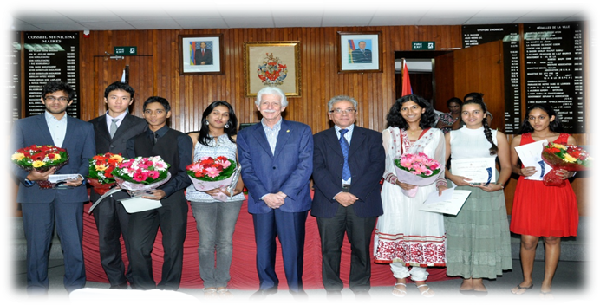

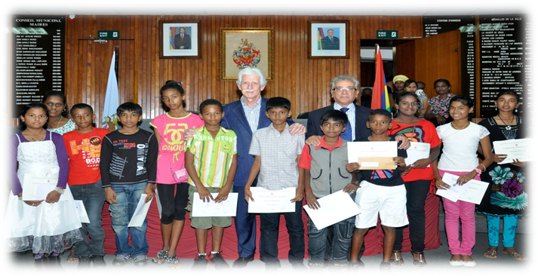

Varusha Pirrappu
A cultural Programme was organised on 14 April 2014, plaza yard and the following facilities were extended: financial grant, decorations, bouquet, transport facilities, electrical point.

Labour Day: A talk (with different religious bodies) was organised for the Municipal Employees in the Municipal Council Room on 30 April 2014.

Mother’s Day Celebration – A get together was organised on 23rd May 2014 for the Municipal Employees (Ladies only)

Music Day
A Musical Concert in collaboration with Radio 1 was organised on 21 June 2014 at Plaza Yard, Rose Hill.




Shabe-Baraat
-General cleaning of Cemetry and lighting facilities.

Inter-Quartiers Basketball Tournament in collaboration with Mauritius Basket Ball Federation was held from 27th July to 10 August 2015 for the following regions: Barkly, Chebel, Vuillemin, Buswell, Tréfles/Stanley, NHDC/Camp Levieux, Mare Gravier, Plaisance

Laying of foundation Stone of Funeral Parlour – on Friday 1st August 2014 at NHDC Camp Levieux.

Eid –ul –Fitr
- Financial Grant
- Cleaning around the vicinity of associations/mosques
- Scavenging services and Plastics Bags
- Lighting Services
- An Eid Gathering in collaboration with Maulana Abdul Aleem Siddiqui Mosque was held on 15th August 2014 at Hugnin Road Rose Hill (Parking Space)

Assumption of the blessed Virgin Mary
Cakes were distributed on 14 August 2014 to hospices and Churches of the town .

Laying of Foundation Stone: Bibliothéque municipal at Tréfles on 22 August 2014.

Ganesh Chathurthi
The following facilities were provided: financial grant, chairs, scavenging services, plastics bags, lighting and garlands.

Pilgrimage Father Laval
- Centre D’acceuil at Emmaus on 8th September 2014
- Facilities such as tent, financial grant, public address, transport were extended to NGO’s/Associations.

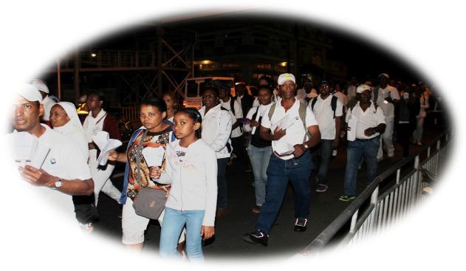

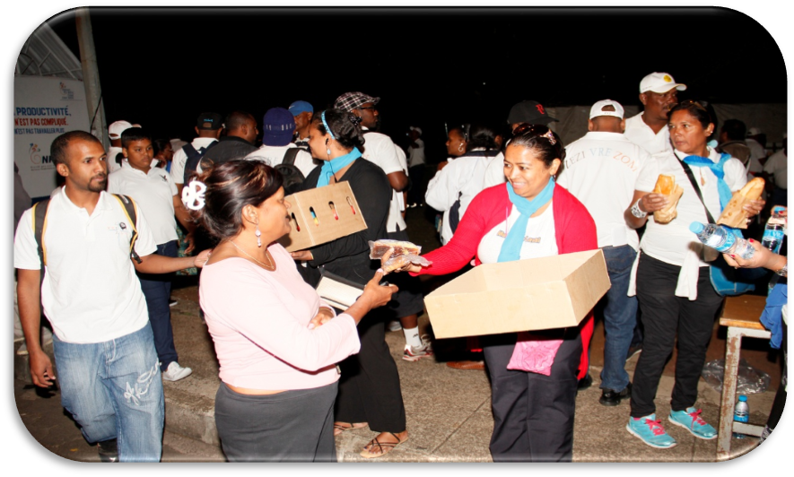

Govinden
The following facilities were extended: cleaning, scavenging services, plastic bags and lightings and garlands.

Renaming of Mare Gravier Municipal Centre into ‘Mare Gravier Jacqueline Manique Municipal Centre’ on 21 September 2014.

A.U.A Activities – Jeux des Villes (27th September – 5th October 2014)
The following Sports Activities were organised: Football, Basketballl, Volleyball, Handball, Table Tennis, Badminton, Relais Pedestre, Athletisme, Petanque, La Boxe.

Opening Ceremony : defile from Plaza yard to Sir Gaetan Duval Stadium on Saturday 27 September 2014
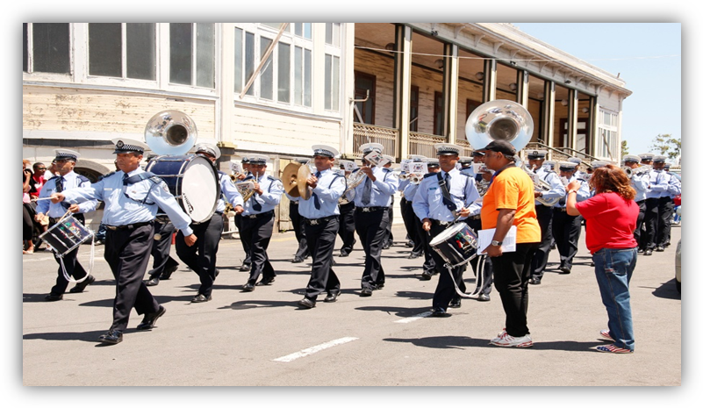
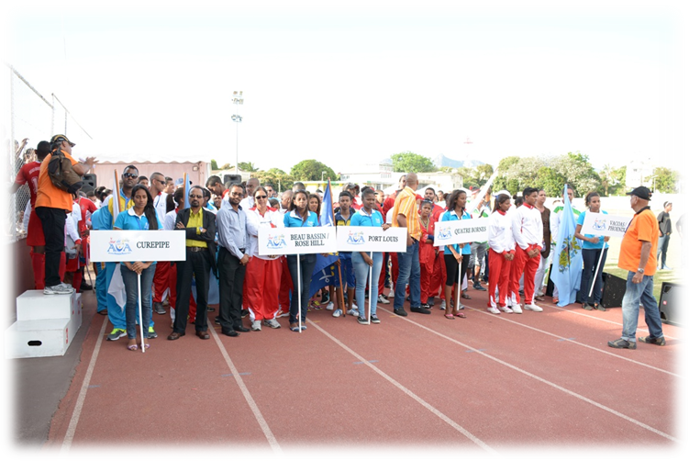

Presentation des athletes de chaque ville
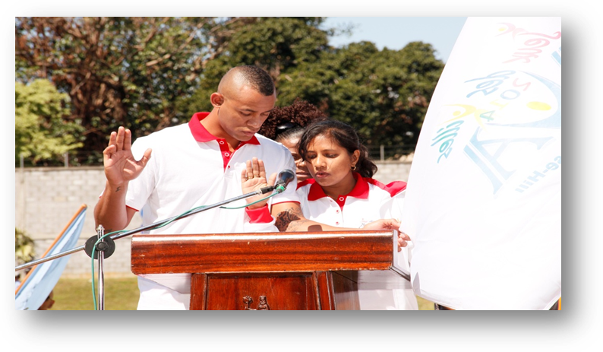
Prestation de serment par les athletes de la ville

Journee Athletisme-samedi 04 octobre 2014


Relais filles

Saut en longeur par athlete de la ville de Vacoas -Phoenix

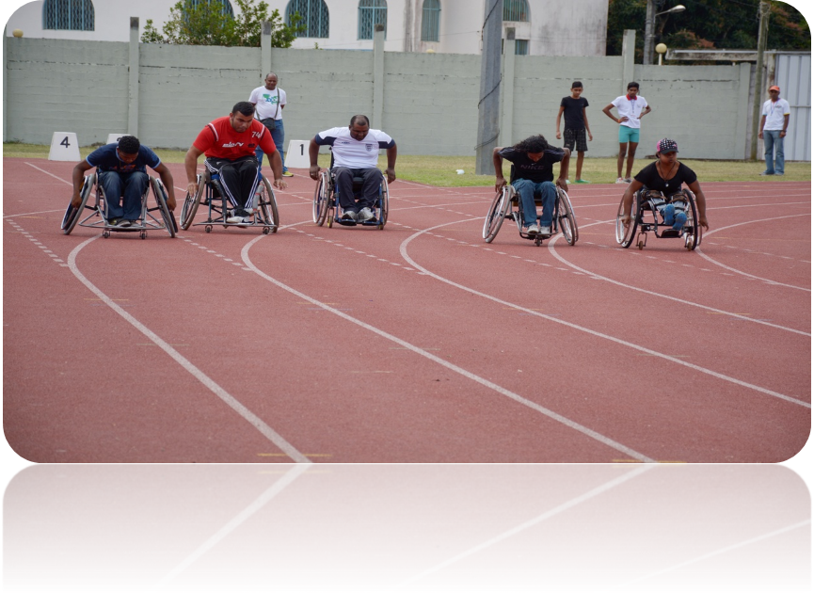

Handisports

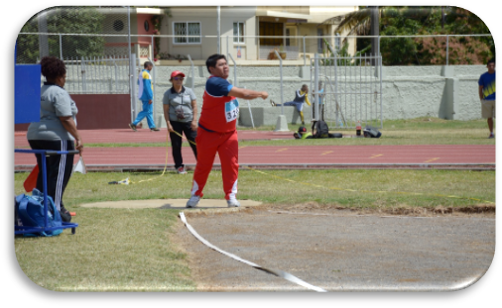
Lance marteau par athlete de la ville


Boxing competition held on Saturday 04 0ctober 2014 at Centre de Boxe, Plaisance

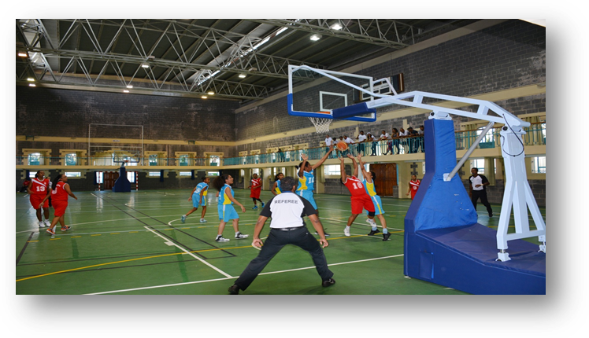
Basketball tournament at Quorum gymnasium( BBRH TEAM V/S CUREPIPE TEAM)

Closing of Ceremony onSunday 05 october 2014 at Sir Gaetan Duval stadium

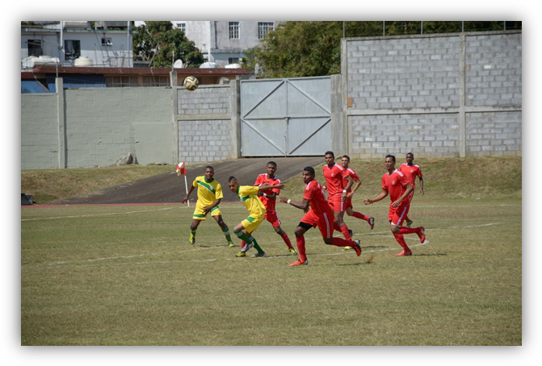
FINAL FOOTBALL TOURNAMENT (VACOAS –PHOENIX TEAM V/S BBRH TEAM)

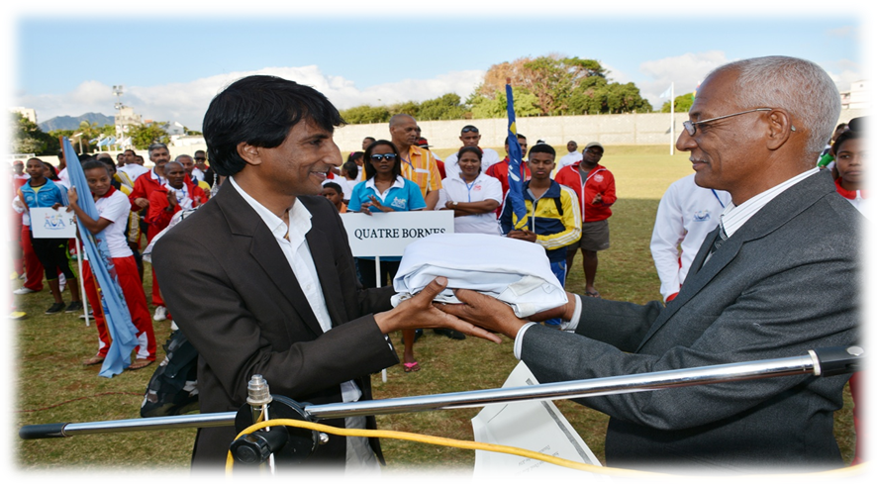

REMISE DU DRAPEAU AUA AU MAIRE DE VACOAS -PHOENIX

Durga Puja
The following facilities were extended: cleaning, scavenging services, plastic bags and lightings and garlands.

Divali
A Divali Nite was organised in collaboration with Stanley Kali Mandir, Stanley Arya Samaj, Tréfles Arya Samaj, Surveyswarnath Mandir, IMCA on 24 October 2014 at Ste Anne Road, Stanley (Bar Chacha).

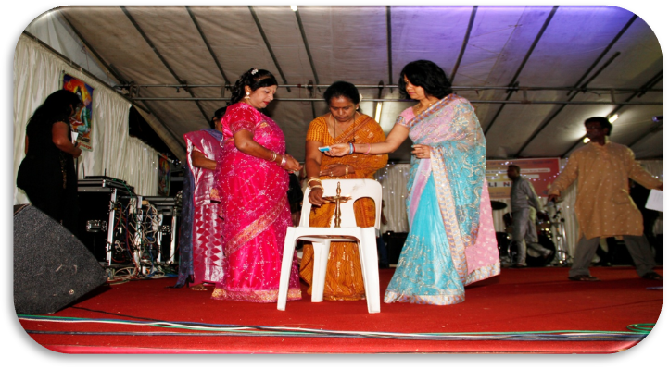

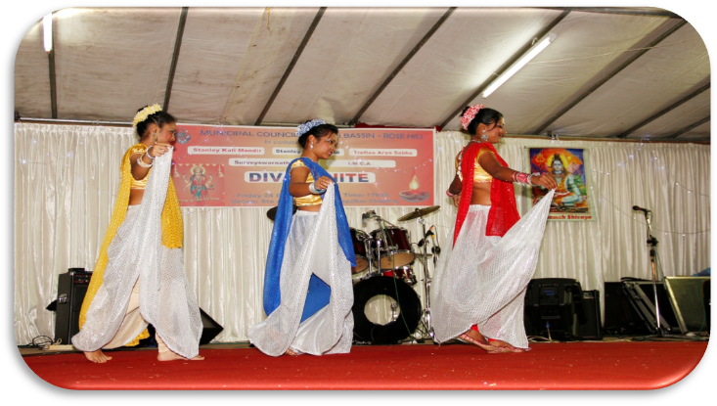

Christmas
- A Christmas Carol was organised on 20 December 2014 in collaboration with “Les Cloches D’or de Notre Dame De Lourdes’’ at the Plaza Yard, Rose Hill.
- Toys were distributed to children of the different regions of Beau Bassin Rose Hill
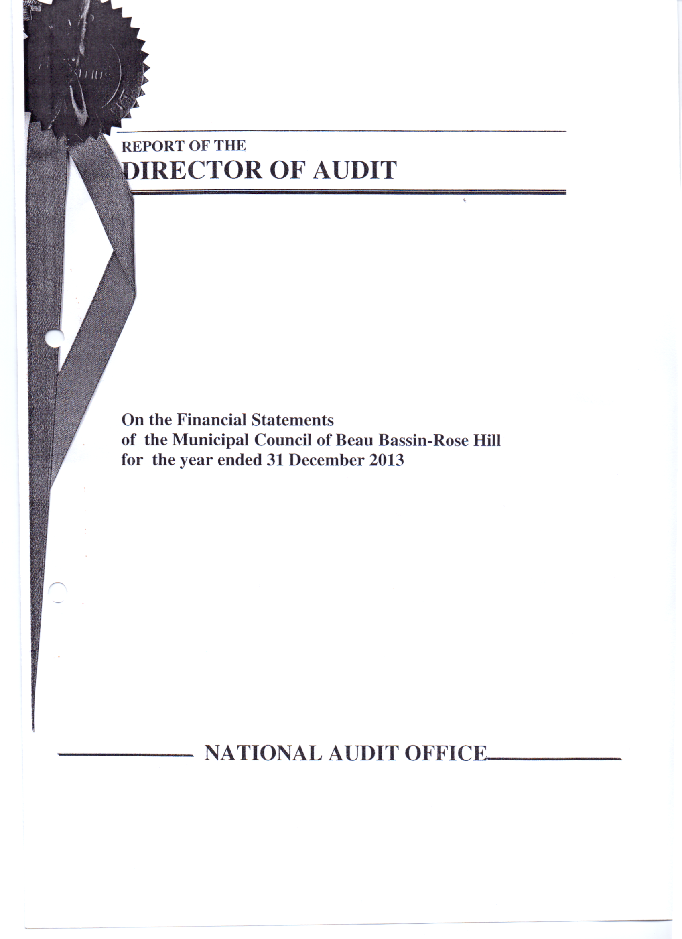
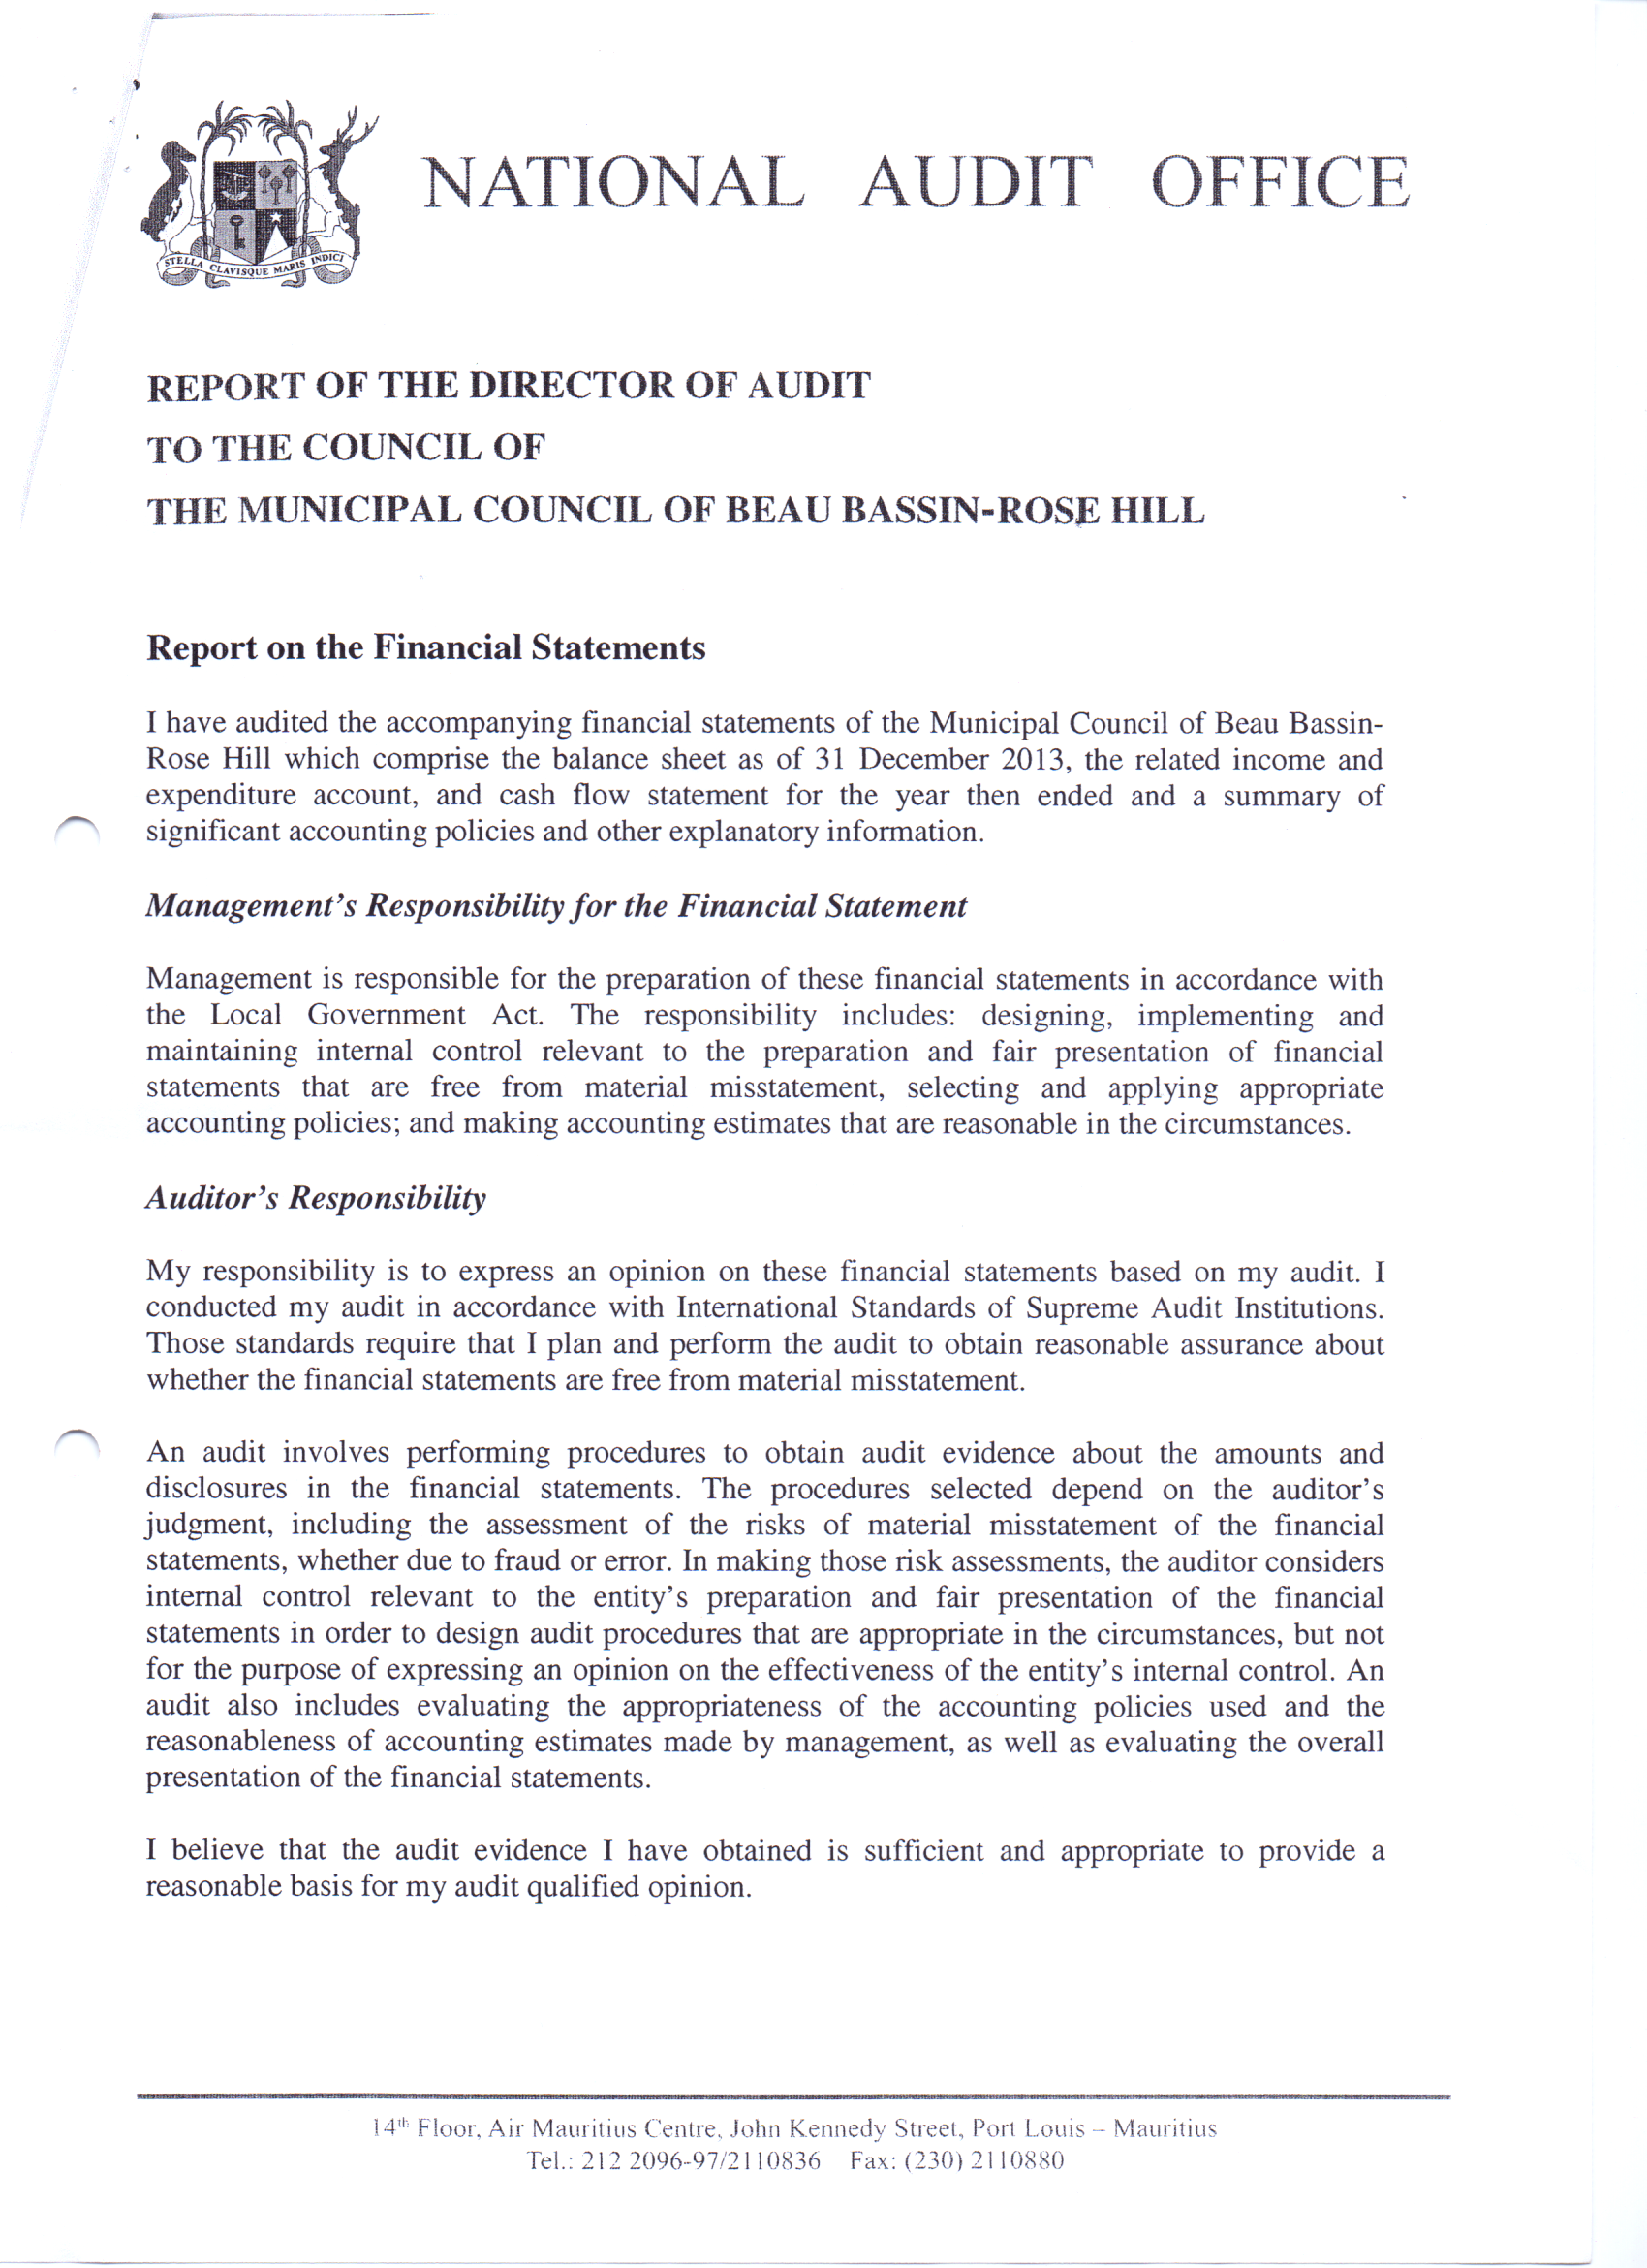

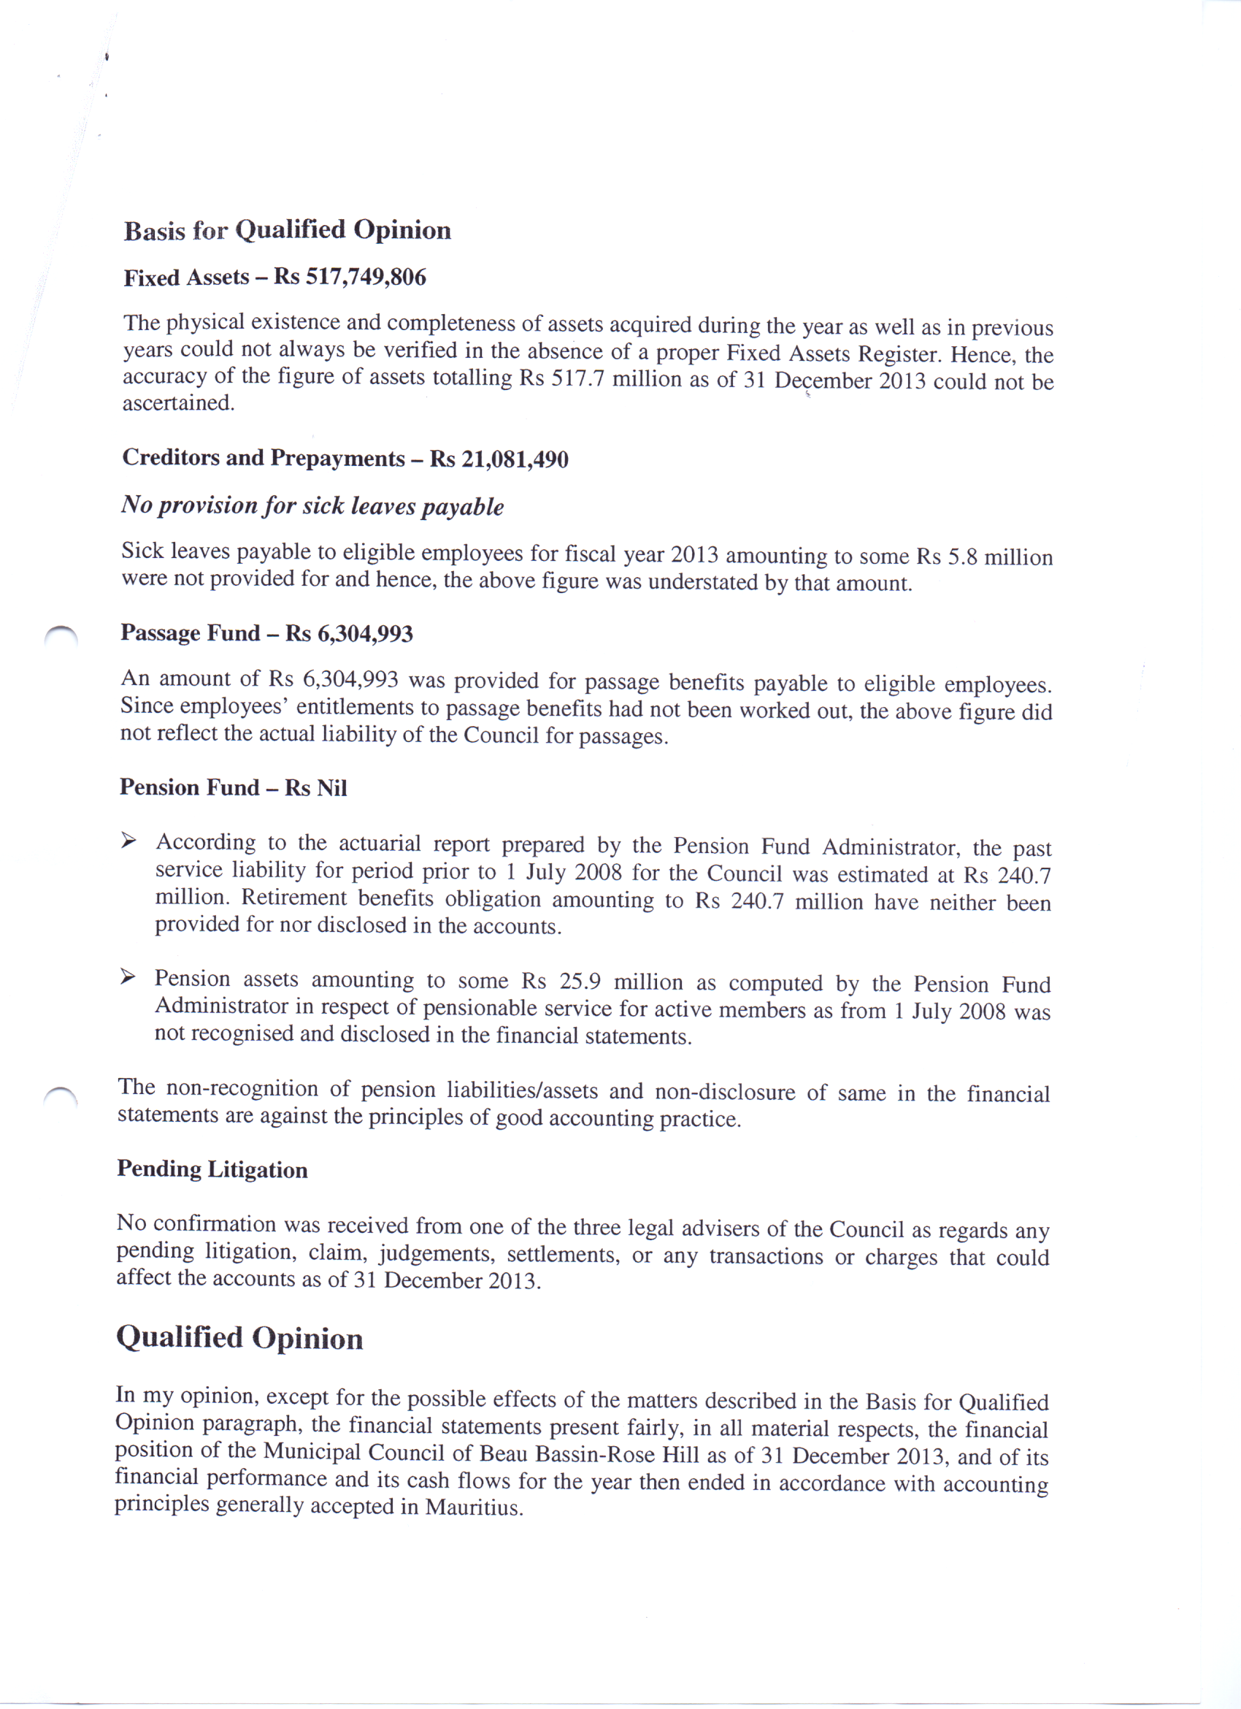

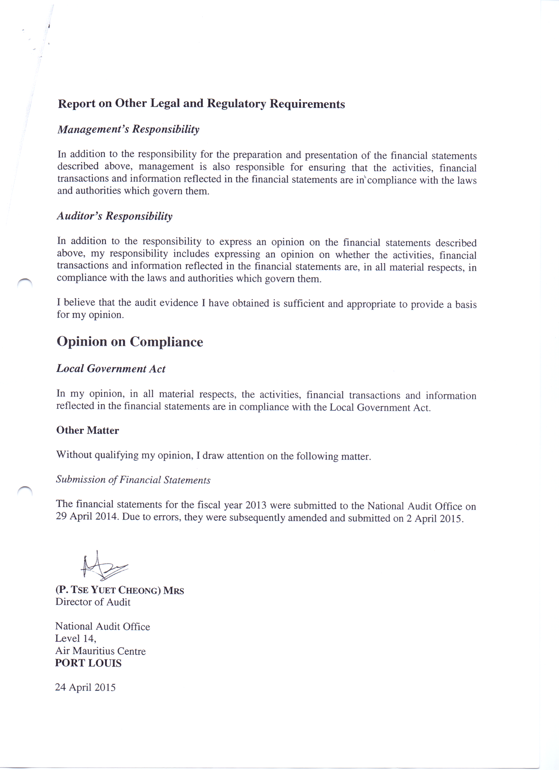

STATEMENT OF CASH FLOWS (UNAUDITED)
For the year ended 31 December 2014

JAN - DEC 2013 |  |  |  |  |  |  | JAN - DEC 2014
Rs |  |  |  |  |  |  | Rs |  | Rs
 |  | OPERATING ACTIVITIES
250,703,725.00 |  | Cash received from Grants-In-Aid |  |  |  |  | 287,672,000.00
42,981,095.66 |  | Cash received from rates and taxes |  |  |  |  | 48,564,080.56
19,240,500.00 |  | Cash received from Fees-8th Schedule |  |  |  |  | 26,668,100.00
76,820,577.37 |  | Cash received from other sources |  |  |  |  | 55,131,897.09
389,745,898.03 |  |  |  |  |  |  | 418,036,077.65
(114,865,519.71) |  | Cash payments to Suppliers/Contractors etc |  |  |  |  | (175,013,300.56)
(282,689,634.03) |  | Cash paid to and on behalf of employees |  |  |  |  | (293,137,053.11)
(7,809,255.71) |  | Net cash Inflow/(Outflow) from Operating Activities |  |  |  |  |  |  | (50,114,276.02)
 |  | RETURNS ON INVESTMENT AND SERVICING OF FINANCE
2,815,547.80 |  | Interest received on Investment |  |  |  |  | 2,633,619.99
(74,871.63) |  | Interest paid on Loan |  |  |  |  | -
2,740,676.17 |  | Net Cash Inflow from R.O.I and S.O.F |  |  |  |  |  |  | 2,633,619.99
 |  | INVESTING ACTIVITIES
(22,523,863.07) |  | Payments to increase Capital Outlay |  |  |  |  | 26,906,945.54
(4,252,970.00) |  | Car Loan to Employees |  |  |  |  | 4,539,750.00
379,640.50 |  | Receipt from sale of fixed assets |  |  |  |  | 527,000.00
(22,598,826.70) |  | Increase/(Decrease) in Investment |  |  |  |  | 10,548,271.36
(48,996,019.27) |  | Net Cash Outflow from Investing Activities |  |  |  |  |  |  | 42,521,966.90
 |  | FINANCING ACTIVITIES
- |  | Government Grants Received |  |  |  |  | 10,100,000.00
18,367,173.81 |  | Capital Grant Received |  |  |  |  | 21,222,261.64
(1,500,000.00) |  | Redemption of Loans |  |  |  |  | -
16,867,173.81 |  | Net Cash Inflow from Financing Activities |  |  |  |  |  |  | 31,322,261.64
(37,197,425.00) |  | Net Increase/(Decrease) in Cash and Cash equivalents |  |  |  |  |  |  | 26,363,572.51
120,596,536.52 |  | Cash & Cash Equivalents as at 01 Jan 2014 |  |  |  |  |  |  | 83,399,111.52
83,399,111.52 |  | Cash & Cash Equivalents as at 31 December 2014 |  |  |  |  |  |  | 109,762,684.03

STATEMENT OF REVENUE AND EXPENSES (UNAUDITED)
For the period ending 31 December 2014
Jan-Dec 2013 |  |  |  |  |  | Note | Jan - Dec 2014
Rs |  |  |  |  |  |  | Rs |  | Rs
 |  | INCOME
266,062,725.00 |  | Government Grant-In-Aid |  |  |  |  | 291,517,000.00
46,762,148.00 |  | General Rates |  |  |  |  | 47,112,410.16
1,352,377.66 |  | Investment Income |  |  |  |  | 2,106,611.08
8,695,606.05 |  | Rentals |  |  |  |  | 10,651,954.81
19,240,500.00 |  | Fees-8th Schedule |  |  |  |  | 26,668,100.00
3,127,059.00 |  | Permits |  |  |  |  | 3,347,536.10
2,089,970.92 |  | Other Income |  |  |  |  | 4,054,080.63
347,330,386.63 |  |  |  |  |  |  |  |  | 385,457,692.78
 |  | EXPENDITURE
216,914,197.42 |  | Staff Costs |  |  |  | 4.00 | 233,965,900.41
54,316,258.24 |  | Supplies & Services |  |  |  |  | 56,758,457.31
8,691,895.80 |  | Transport costs |  |  |  |  | 8,799,706.95
3,162,980.87 |  | Other Administration Costs |  |  |  | 5.00 | 2,224,171.03
4,520,308.05 |  | Social and Cultural Activities Expenses |  |  |  |  | 5,127,705.38
1,854,871.63 |  | Financial Charges |  |  |  |  | 1,610,000.00
2,809,989.67 |  | Grants and Subsidies |  |  |  |  | 3,479,426.58
- |  | Contribution to Funds |  |  |  |  | 10,000,000.00
57,581,076.00 |  | Pensions and Gratuities |  |  |  |  | 58,909,064.52
349,851,577.68 |  |  |  |  |  |  |  |  | 380,874,432.18
(2,521,191.05) |  | Surplus/(Deficit) For The Year |  |  |  |  |  |  | 4,583,260.60

STATEMENT OF FINANCIAL POSITION (UNAUDITED)
as at 31 December 2014
31.12.2013 |  |  |  |  | Note |  | 31.12.2014
Rs |  |  |  |  |  |  | Rs |  | Rs
 |  | FIXED ASSETS
452,396,711.84 |  | Capital outlay |  |  | 2.01 |  | 478,084,330.12
65,353,094.37 |  | Other Long Term Outlay |  |  | 2.02 |  | 74,184,480.98
517,749,806.21 |  |  |  |  |  |  |  |  | 552,268,811.10
 |  | CURRENT ASSETS
1,800,074.94 |  | Stocks |  |  | 1.02 |  | 2,288,158.65
42,130,128.97 |  | Debtors |  |  | 3.00 |  | 45,380,084.28
6,086,198.15 |  | Advances Car Loan |  |  |  |  | 8,665,465.64
26,000,000.00 |  | Investments |  |  |  |  | 24,000,000.00
100.00 |  | Cash in Hand |  |  |  |  | 100.00
83,399,111.52 |  | Bank |  |  |  |  | 109,762,684.03
1,350,222.61 |  | Accruals |  |  |  |  | 2,345,745.93
160,765,836.19 |  |  |  |  |  |  | 192,442,238.53
 |  | LESS CURRENT LIABILITIES
21,081,490.35 |  | Creditors & Prepayments |  |  |  |  | 25,481,405.58
12,287,823.77 |  | Deposits |  |  |  |  | 17,111,373.68
- |  | Sick Leave |  |  |  |  | 6,635,912.94
33,369,314.12 |  |  |  |  |  |  | 49,228,692.20
127,396,522.07 |  | NET CURRENT ASSETS/(LIABILITIES) |  |  |  |  |  |  | 143,213,546.33
645,146,328.28 |  | TOTAL ASSETS |  |  |  |  |  |  | 695,482,357.43
 |  | FINANCED BY
591,681,995.94 |  | General Fund |  |  | 7.00 |  | 626,059,113.22
6,304,993.48 |  | Passage Fund |  |  |  |  | 15,875,662.41
42,959,338.86 |  | Revenue Reserve |  |  |  |  | 50,747,581.80
640,946,328.28 |  |  |  |  | 6.00 |  |  |  | 692,682,357.43
 |  | LONG TERM LIABILITIES
4,200,000.00 |  | Advance from Ministry of Finance |  |  |  |  | 2,800,000.00 |  | 2,800,000.00
645,146,328.28 |  |  |  |  |  |  |  |  | 695,482,357.43

THE MUNICIPAL COUNCIL OF BEAU BASSIN - ROSE HILL
SERVICES PROVIDED AND PERFORMANCE INFORMATION
PROGRAMME 1: Policy and Management of the Council
Outcome: Improved quality of life of Citizens through the provision of services that respond to their needs by exercising sound administrative and financial control. |  |  | 2014 Target
Outcome Indicator: |  |  | 95%
DELIVERY UNITS | SERVICES TO BE PROVIDED | PERFORMANCE
DELIVERY UNITS |  | Services Standards | 2014 Targets
Administration Department | O1: Council's Policies implemented | P1:Percentage of Policy measures actually implemented | 95%
Administration Department | O2: PBB delivery of Council's programmes | P1: Percentage of PBB indicators met | 85%
Administration Department | O3: Attendance to complaints and suggestions | P1: Percentage response to public queries | 95%
Finance Department | O4: Revenue estimates for budget formulated carefully to be close to actual | P3: Variance from actual not above | 10%
Finance Department | O5: Revenue Collection | P4: Percentage reduction in outstanding debt/arrears | 10%
PROGRAMME 2: Provision and Maintenance of Community Based Infrastructure and Amenities
Outcome: Access to modern and well maintained community infrastructure |  |  | 2014 Target
Outcome Indicator: |  |  | 90%
DELIVERY UNITS | SERVICES TO BE PROVIDED | PERFORMANCE
DELIVERY UNITS | (Outputs) | Indicators | 2014 Targets
Public Infrastructure Department | O1: Construction and Maintenance of Roads | P1: Area of roads constructed and maintained | Constructed: 1819m2 Maintained: 18,000m2
Public Infrastructure Department | O2: Construction and Maintenance of Drains | P1: Length of drains constructed and maintained | Constructed: 321m/run Maintained: 5,000m/run
Public Infrastructure Department | O3: Maintenance & Installation of Streetlighting points | P 1: Number of streetlighting points installed and maintained | Installed: 125 lanterns Maintained: 12000 points
Public Infrastructure Department | O4: Road marking and traffic signs fixed | P1: Length of road marking effected (Area) | 15,000m2
Public Infrastructure Department | O4: Road marking and traffic signs fixed | P2: Number of traffic signs fixed | 150 units
Public Infrastructure Department | O5: Maintenance of Councils Assets eg Buildings,sports infrastructure | P1: Percentange of maintenance attended to | 90%
Public Infrastructure Department | O6: Key Infrastructure projects implemented | P1: Number & Percentage completion of project started | 95%
PROGRAMME 3: Development control within the Council's Area
Outcome: A harmonious and orderly development within the Council's area. |  |  | 2014 Target
Outcome Indicator: |  |  | 90%
DELIVERY UNITS | SERVICES TO BE PROVIDED | PERFORMANCE
DELIVERY UNITS | (Outputs) | Indicators | 2014 Target(s)
Planning and Health Department | O1:Issuing of Building and Land Use Permit | P1: Percentage of applications processed | 100%
Planning Department | O2: Updated Cadastre | P2: Percentage of new properties surveyed | 88%
Health Department | O3: Ex Post Control | P2: Percentage of new trading activities controlled | 75%
PROGRAMME 4: Sound and Healthy Conditions in the Council's Area
Outcome(s): To ensure that people are satisfied with the quality of service provision committed by the Council.
DELIVERY UNITS | SERVICES TO BE PROVIDED | PERFORMANCE
DELIVERY UNITS | (Outputs) | Indicators | 2014 Target(s)
Health and Environment Department | O1: Refuse collection service | P1: Number of times households serviced per week | Once Weekly
Health and Environment Department | O1: Refuse collection service | P2:Number of times commercial places serviced per week | Daily
Health and Environment Department | O2: Cleaning public places (including green spaces,cemeteries and traffic centres) | P1:Frequency of cleaning operations carried out | Daily
Health and Environment Department | O3: Rodent and Pest Control | P1:Frequency of interventions effected/sites covered | Twice Monthly
Health and Environment Department | O4:Information,Education and Communication (IEC) | P1: Number of IEC organised | Five
PROGRAMME 5: Promotion of Sports, Welfare,Education and Cultural Development
Outcome: To provide access to socially oriented and recreational activities. |  |  | 2014 Target
Outcome Indicator: |  |  | 90%
DELIVERY UNITS | SERVICES TO BE PROVIDED | PERFORMANCE
DELIVERY UNITS | (Outputs) | Indicators | 2014 Target(s)
Welfare Department | O1: National festivities celebration | P1: Number of cultural shows organised | 15
Welfare Department | O2: Organisation of Sports activities | P1: Number of sports activities organised | 35
Library | O3: Provision of I.T, Literary and other facilities | P1: Number of persons getting access to facilities being provided by the council | 127,000
Library | O3: Provision of I.T, Literary and other facilities | P2: Number of children attending pre primary school run by the council | 300

